**CHAPTER III**

**TECHNICAL BACKGROUND**

This chapter will present the technical considerations in developing the VirtualShrine: An Interactive Museum Website for Casa Real Shrine. The project approach, conceptual framework, Visual Table of Contents (VTOC) of Casa Real Shrine, conceptual system design, security matrix, and deployment diagrams will be discussed.

**Project Methodology**

The quantitative technique will be used in the study to collect data from visitors of the Casa Real Shrine of Malolos. The proponents will gather statistics on visitor satisfaction comparing the present museum operations without the website and the museum operations after the website is implemented.

The research and development element of the design involves (1) analyzing the existing museum operations, (2) innovating and developing a system based on the findings, and (3) testing the efficacy of the innovation.

The approach includes a quantitative examination of the program/system, its components, as well as implementation and outcome data. Essentially, the procedure includes conducting comprehensive documentation analysis.

The study will use an agile method for research, it is based on based on iterative development, where requirements and solutions evolve through collaboration between self-organizing cross-functional teams. can help develop the features of the Casa Real Virtual Museum.

According to Altameem E. (2015), Agile is an important tool in software development because this methodology addresses the common project drawbacks including schedule predictability, scope creep and costs. The team members are also able to work effectively and accomplish the project tasks and increase motivation to the team that cause to increase in creativity and innovativeness thus delivering a high-quality software.

**Conceptual Framework**

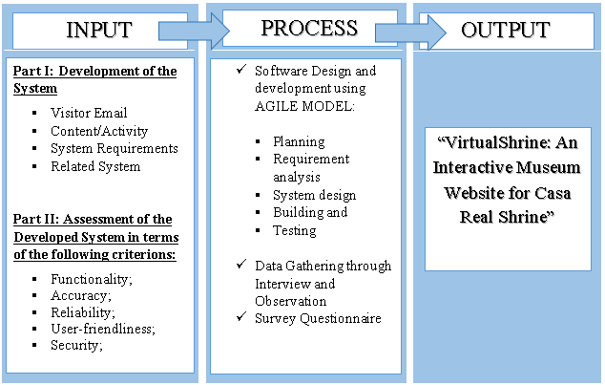

**Figure 1.** **Conceptual Model of the System Development**

The first frame is the input stage wherein it involves the primary data and information of the Casa Real Shrine to develop the system. System Requirements is necessary to have the hardware and software requirements needed to develop the system. Related Systems in books, internet articles, related studies and online research will also be reviewed.

The second frame is the process stage, wherein this part of the diagram the proponents adopted the System Development Life Cycle (SDLC) is a conceptual model used in project management that describes the stages involved in an information system development project, from a first feasibility study through maintenance of the completed application. SDLC can apply to technical and non-technical systems. In most use cases, a system is an IT (Information Technology) technology such as hardware and software. Project and program managers typically take part in SDLC, along with system and software engineers, development teams and end-users.

In development of the system the proponents will be using the Agile model. Agile model believes that every project needs to be handled differently and the existing methods need to be tailored to best suit the project requirements. In Agile, the tasks are divided into time boxes (small time frames) to deliver specific features for a release. Iterative approach is taken and working software build is delivered after each iteration. Each build is incremental in terms of features; the final build holds all the features required by the customer.

Agile uses an adaptive approach where there is no detailed planning and there is clarity on future tasks only in respect of what features need to be developed. There is feature driven development and the team adapts dynamically to the changing product requirements. The product is tested very frequently, through the release iterations, minimizing the risk of any major failures in future. It has five phases from planning, requirement analysis, system design, building, and testing. The Agile SDLC model is a combination of iterative and incremental process models with a focus on process adaptability and customer satisfaction by rapid delivery of working software products. Agile Methods break the product into small incremental builds.

Lastly, for the Output stage, this is the proposed system, the VirtualShrine: An Interactive Museum Website for Casa Real Shrine.

 In order to construct the system, each SDLC phase in the Process stage is discussed below.

**Initiation Phase**

The initiation phase begins when the client identifies the idea, need, or chance to improve the system. The purpose of the Initiation Phase is to: (a) Identify ways to further improve the system from the current situation that left a dent in visitors count, scarcity relating to the museum. (b) Ideally is to provide answers to every occurring problem.

         In this study, Virtual Shrine focused on the virtualization of the museum for visitors reassuring the safety of the visitors without compromising any content and added content as well. Adding Online Booking Admission to the system will add more security for data.

         And popular museums have done online 3D virtual tours around 1999, boosting the number of visitors both online, and in person, using the technology now as an advantage to the system. Through an online web-based system the visitors can take the tour anytime and with the Online Booking making it convenient for any visitors.

         Attentiveness to the systems performance will make sure the plans will proceed as intended in the project for a higher chance of success.

         Upon approval of the proposed system, VirtualShrine: An Interactive Museum Website for Casa Real Shrine used the feasibility study and support documentation to begin the planning phase.

**Planning Phase**

The Planning phase is a step before developing a software. This will help the developers to avoid problems in the early stage of developing the project that might help them for the future of the software. In creating the VirtualShrine website, the features of the software are important for the developers. That's why creating a plan is a must for the satisfaction of their audience.

A project becomes nothing more than a collection of tasks without a plan. The challenge for most businesses is not whether or not they have a plan, but how well that plan has been laid out and implemented. Weedmark (2019)

Weedmark (2019) also added that there are aspects for a good project plan. (a)Describe the project. This will state the main objective of the problem and problem that they may encounter, and they can solve it. The proponents of Casa Real Virtual Museum are going to reintroduce the importance of museum to the new generation of people. (b) Break down the project into specific tasks. Make certain that each activity flows naturally into the next. Since the project has many features, the proponents need to divide the task to different members including the developers. (c) Estimate the resources required for the project and make a resource plan to guarantee that the appropriate resources are gathered successfully. Creating the virtual museum needs a device to fulfill other features including 360 cameras for the virtual tour and personal computer/laptops on creating the project. (d) Develop the project schedule since the task is divided you also need to include a due date. The Proponents need to value the time of the project since the project is big time is important to avoid problems that can affect the project. (e) Develop a communication plan. Communication is a must for the proponents to make sure the project development is improving, and it includes the client for their suggestions and problems about the given project. (f) Write the statement of Work (SoW) This document outlines the tasks to be completed, deliverables, and the intended outcome once the project is completed. The proponents of Casa Real Virtual Museum should complete all the given tasks and to make sure to always consult in the Management of Casa Real Shrine to fulfill all the requirements they need.

**Design Phase**

The Design Phase includes turning every gathered information, functions, and request during the initiation and planning phases into a well-constructed design with specifications that developers use to create systems during the development phase.

As used in this study, with a thorough look at ideas for the designs, it seems there are numerous ways to implement program designs. Using Object Oriented Analysis and Design (OOAD), to identify and connect important parts or components, expanding layouts to verify each branch of systems and connections.

         Contemporary design techniques are commonly used because of its minimalist design that aren’t outdated, due to its popularity that can be used as a tool in prototyping that creates the basic foundation of items such as the layouts, system architectures. Providing end-users, designers and programmers with digital prototyping should inspect the presented prototype design in an iterative process until the design is on par with the ideal design.

         However, in designing the website for VirtualShrine, the management is very open to any ideas and will also be prepared to make changes even after presenting the system design.

         It is also important to document the complete design precisely by the designer with specific details to aid the programmer in developing and changes it may encounter. The full document will also provide help in managing the final output of the program and to verify if the system followed the original goals.

**Development Phase**

Converting the design phase into executable programs is part of the development phase.

Effective development standards at this point include specifications that the researchers design before programming begins. The processes aid in the comprehension of program designs and functional requirements.

Many programmers employ a variety of strategies to create computer programs. Procedural programming approaches have traditionally been used to construct big transaction-oriented programs connected with financial organizations. Line-by-line scripting of logical instructions that are combined to make a program is what procedural programming entails. The generation and testing of source code, as well as the refinement and finalization of test strategies, are all important procedural programming tasks. Individual programmers often write and test program modules or components, which are little routines within an application that execute a certain task Completed components are combined with other components and inspected, usually by a group of programmers, to ensure that they work together effectively. As component groups are gradually merged and interfaces between component groups and other systems are tested, the process continues.

In developing the Casa Real Shrine Museum website, system documentation includes the system description which provides the explanations of operating environments as well as the interconnected input, processing, and output operations of integrated application systems.

System flowcharts and models identify the source and kind of input information, processing and control actions and the nature and location of output information as part of the system documentation.

Flowcharts have traditionally been used by designers and developers to show graphical perspectives of procedural program sequencing. Flowcharts are a useful tool for illustrating complicated programs and processes. There is flowcharting software available that can automatically chart programs or allow programmers to dynamically chart programs without having to design them manually.

Operator instructions for all processing applications should be established by organizations. The instructions should detail how to complete certain tasks, as well as how operators should respond to system requests or interruptions. Only information relevant to the computer operator's job should be included in the documentation. An operator should not have access to program documentation such as source listings, record layouts, or program flowcharts. Operator instructions should be detailed enough that an experienced operator unfamiliar with the application can effectively complete a program without assistance.

End-user instructions that define how to use the museum website were also established by the built system. Operation manuals, online help features, and system error messages are all examples of instructions that help operators to manage the back end.

**Testing Phase**

Organizations must undergo a beta test during the testing phase to ensure the accuracy of programmed code, the inclusion of desired functionality, and the website's compatibility. Thorough testing is required to ensure that systems meet the needs of the organization and the end users. Testing teams are composed of software engineers and end users who are responsible for gathering and loading representative test data into a testing environment. Finally, testers typically find program faults or errors throughout the testing process. There should be procedures in place to guarantee that programmers address faults as quickly as possible and that any changes or revisions are documented. By decreasing tester downtime, quickly resolving issues enhances testing efficiencies. It also saves a programmer time troubleshooting a section of a program that isn't working because another programmer hasn't debugged a faulty linked code. Corrections and adjustments must be documented in order to maintain the integrity of the overall program documentation.

**Figure 2.** **VirtualShrine: An Interactive Museum Website for Casa Real Shrine of Malolos Gantt Chart**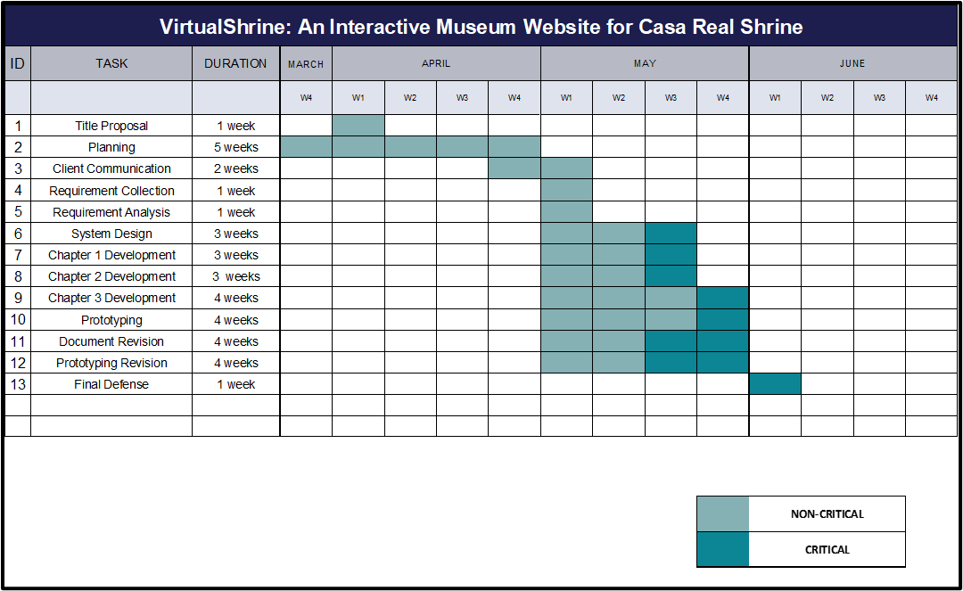

The Gantt Chart, as illustrated in Figure 2, depicts the schedule that the system's proponents will follow during its development. The Gantt Chart will also be used to track the progress of the system's development.

**Implementation Phase**

The implementation phase involves an approved website into production environments. In this stage, the primary tasks include the implementation schedule, training end users, and access to the website. In addition, Casa Real Shrine should input and verify data, configure, and test system and security parameters, and conduct post-implementation reviews.

Verifying the input data and security parameters for accuracy is an important element of the implementation process. Organizations frequently run a new system alongside an old system until the new system's quality and reliability are verified. During the verification process, employees should document any programming, procedural, or configuration changes.

**Project Evaluation**

In this stage, management should perform post-implementation evaluations at the end of a project to confirm that project objectives have been met and to evaluate project management actions. Management should conduct interviews with all people and staff members who are actively involved in the operational usage of a product or document and resolve any issues that are discovered.

**Maintenance Phase**

It entails making changes to software and documentation to support its operational effectiveness throughout the maintenance period. It entails making modifications to improve a system's or website's performance, resolve issues, increase security, and meet user needs. The museum should implement suitable change management standards and procedures to guarantee that alterations do not disrupt operations or harm a system's functionality or security.

**System Design**

**Front Office:** The website's front office consists of the following menus: (1) Home. The Home page is the system's default web page. The home page displays a welcome banner for visitors, as well as a "book a tour" and "plan your visit" buttons for visitors' convenience. The homepage also highlights featured exhibitions and information, upcoming events, galleries, and group trips. The homepage also includes a footer with basic information about the museum, contact information, quick links, and a list of social media pages that visitors can like or follow. (2) Plan your visit. This website displays information on the museum's operations, such as the opening time, location, museum map that can be seen and downloaded in PDF format, and health and safety guidelines that visitors must follow. This website will assist visitors in preparing for their visit to the museum, this way, they will have a hassle-free visit; (3) Booking Reservation. The visitor can book for reservation for their physical museum visit. Pre-booking is recommended to have a hassle-free visit. The visitor will enter the date and time of reservation, and the number of people who will visit; the system will also ask for the representative visitor information such as name, email that will be used for the confirmation, mobile number, address, and the name of company, agency, or school if applicable. At the end of reservation, the visitor will receive an Acknowledgement Receipt on the email they provided with the following details:  (a) Reservation Date and Time; (b) Total number of visitors. (4) Virtual Tour. This page displays the virtual tours such as the permanent and current exhibits, virtual gallery with a 360 view of the 5 galleries available in the museum, and the narrated tours.

**Back Office:** The back office serves as the system administrator and website content manager site where they can view booking lists, approve, or decline bookings, update the website content, post an announcement, and add an assistant admin.

**Head Administrator:** The Head administrator is mainly the museum curators. The Back Office of the head administrator composed of the following menus: (1) Add user. They will be able to register an assistant administrator. (2) Edit user. able to set their own type of user that will be handling the back office. (3) Edit user information. able to modify the assistant admin. (4) Remove user. Has the ability to delete assistant user account in the back office. (5) Reservation. Viewing, approving, and declining of reservation done by the visitor. (6) Update Contents. The head administrator will be able to add, update, and delete the content of the front office.

**Assistant Administrator**: The user of this application is mainly the employee of Casa Real Shrine who handles the booking reservations. The Back Office is composed of the following menus: (1) Log In. The user of the system can log in to access other functions or menus of the system. Required username and password assigned by the head administrator. See security matrix for access role (Table 5); (2) Reservation. Viewing, approving, and declining of reservation done in this module. Any action done by the administrator regarding the status of the reservation application by the client, the system will automatically notify the client via email they provided during the booking process. Reason for declined application must be stated; (3) Update Contents. The assistant administrators can update the content on the website, such as updating the gallery contents, new exhibits, and museum information; (4) Post Announcements. Posting of announcements and events. Figure 3 shows the flow chart of the back-office part of the website. Only the administrator can access the back office of the system.

**System Specifications**

Software Specifications. The system will be developed using Visual Basic .Net and ASP.Net. The Visual Basic .Net and ASP .Net are software under the Visual Studio.NET. These applications will be used in creating web pages as the front-end of the application. The .NET framework features will be used for the well optimized web application.

The PHP Admin will be used as the database application of the web. This will be the storage of data and other information needed by Casa Real Shrine. Jasper Report will be used to display different reports.

**Hardware Specifications**

Hardware Specifications. The performance of the web application is based on the hardware used in deploying the system.

Below are the recommended hardware requirements:

**Table 1**

**Requirements for Web Server**

|  |  |  |
| --- | --- | --- |
| **Hardware Requirement** | **Minimum Requirement** | **Recommended Requirements** |
| Processor | 1.6 GHz CPU | 2 x 1.6 GHz CPU |
| RAM | 1.75 GB RAM | 3.5 GB RAM |
| HDD | 40 GB | 40 GB |

Table 1 shows the requirements for the Web Server. The minimum requirement for the processor is 1.6 GHz CPU and the recommended requirement is 2x1.6 GHz CPU. For RAM, the minimum requirement is 1.75 GB RAM, and the recommended requirement is 3.5 GB RAM. And lastly, for HDD, both the minimum and recommended requirement is 40 GB.

**Table 2**

**Requirements for Database Server**

|  |  |  |
| --- | --- | --- |
| **Database Server Requirement** | **Minimum Requirement** | **Recommended Requirements** |
| Processor | 2x 1.6 GHz CPU | 4 x 1.6 GHz CPU |
| RAM | 3.5 GB RAM | 7 GB RAM |
| HDD | 40 GB | 40 GB |

Table 2 shows the requirements for the Database Server. The minimum requirement for the processor is 2x 1.6 GHz CPU and the recommended requirement is 4x1.6 GHz CPU. For RAM, the minimum requirement is 3.5 GB RAM, and the recommended requirement is 7 GB RAM. And lastly, for HDD, both the minimum and recommended requirement is 40 GB.

**Table 3**

**Requirements for Android Server**

|  |  |  |
| --- | --- | --- |
| **Database Server Requirement** | **Minimum Requirement** | **Recommended Requirements** |
| Processor | ARM Mali-T880 MP4 | ARM Mali-G52 MP2 |
| RAM | 2.5 GB RAM | 7 GB RAM |
| HDD | 40 GB | 40 GB |

Table 3 shows the requirements for the Android Server. The minimum requirement for the processor is ARM Mali-T880 MP4 and the recommended requirement is ARM Mali-G52 MP2. For RAM, the minimum requirement is 2.5 GB RAM, and the recommended requirement is 7 GB RAM. And lastly, for HDD, both the minimum and recommended requirement is 40 GB.

**Table 4**

**Requirements for IOS Server**

|  |  |  |
| --- | --- | --- |
| **Database Server Requirement** | **Minimum Requirement** | **Recommended Requirements** |
| Processor | Apple A4 | Apple A6 |
| RAM | 2.5 GB RAM | 7 GB RAM |
| HDD | 40 GB | 40 GB |

Table 4 shows the requirements for the IOS Server. The minimum requirement for the processor is Apple A4 and the recommended requirement is Apple A6. For RAM, the minimum requirement is 2.5 GB RAM, and the recommended requirement is 7 GB RAM. And lastly, for HDD, both the minimum and recommended requirement is 40 GB.

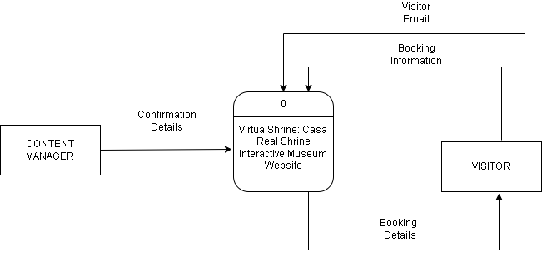

**Figure 3. Context Diagram (Level 0)**

In this level, it displays the input and output of the booking of Casa Real Shrine

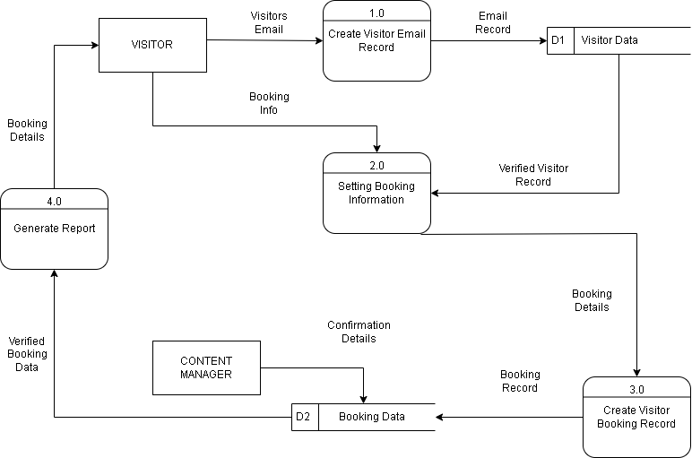

**Figure 4. Data Flow Diagram (Level 1)**

In this level, the system displays the process specifically from the Visitors to the content manager/admin who will interact with the system.

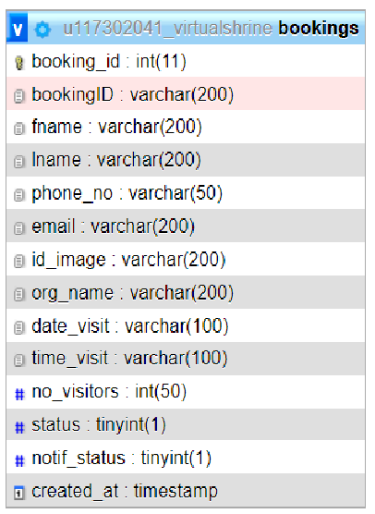

**Figure 5. Entity Relationship Diagram – Booking System**

This figure displays the data for the booking system.

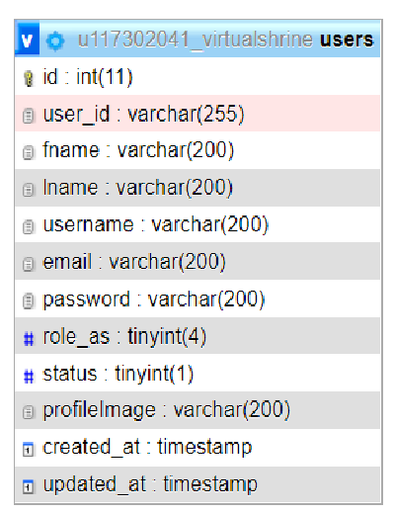

**Figure 6. Entity Relationship Diagram – Admin and Type of User**

This figure displays the data for the Admin User.

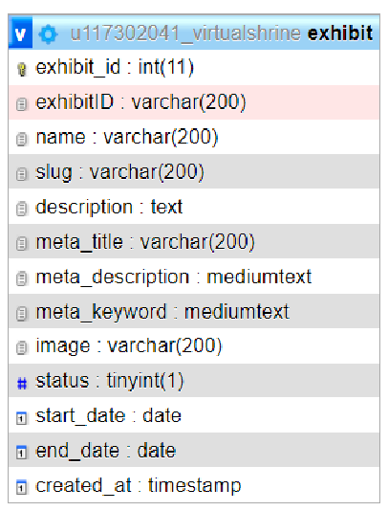

**Figure 7. Entity Relationship Diagram – Exhibit**

This figure displays the data for the Exhibit.

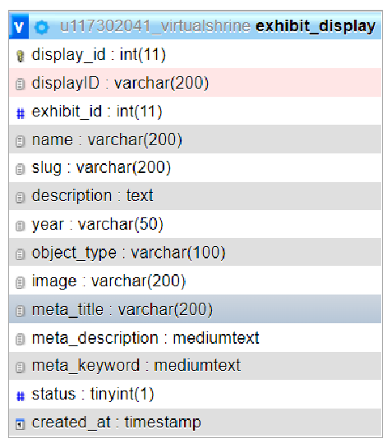

**Figure 8. Entity Relationship Diagram – Exhibit Display**

This figure displays the data for the Exhibit Display.

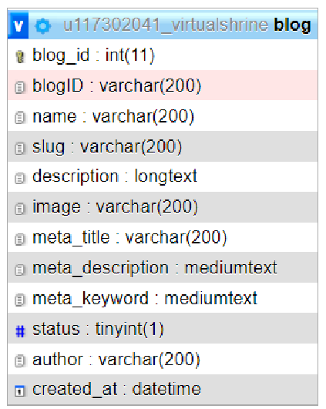

**Figure 9. Entity Relationship Diagram – Blog**

This figure displays the data for the Blog.

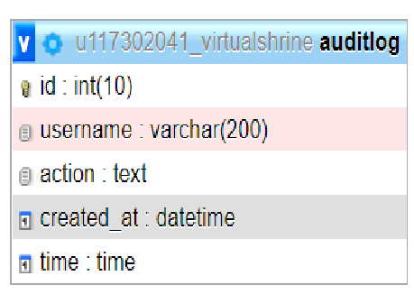

**Figure 10. Entity Relationship Diagram – Audit log**

This figure displays the data for the Audit log.

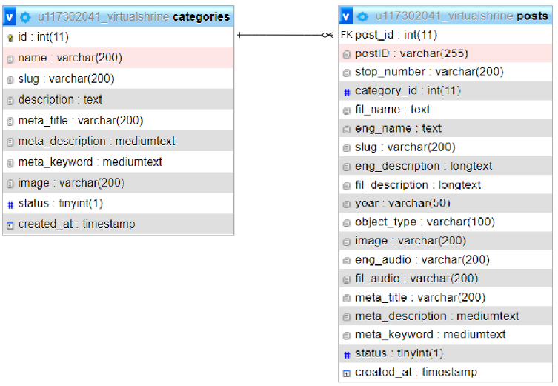

**Figure 11. Entity Relationship Diagram – Categories and Posts**

This figure displays the relationship between categories and posts.

**Figure 12. Use Case Diagram**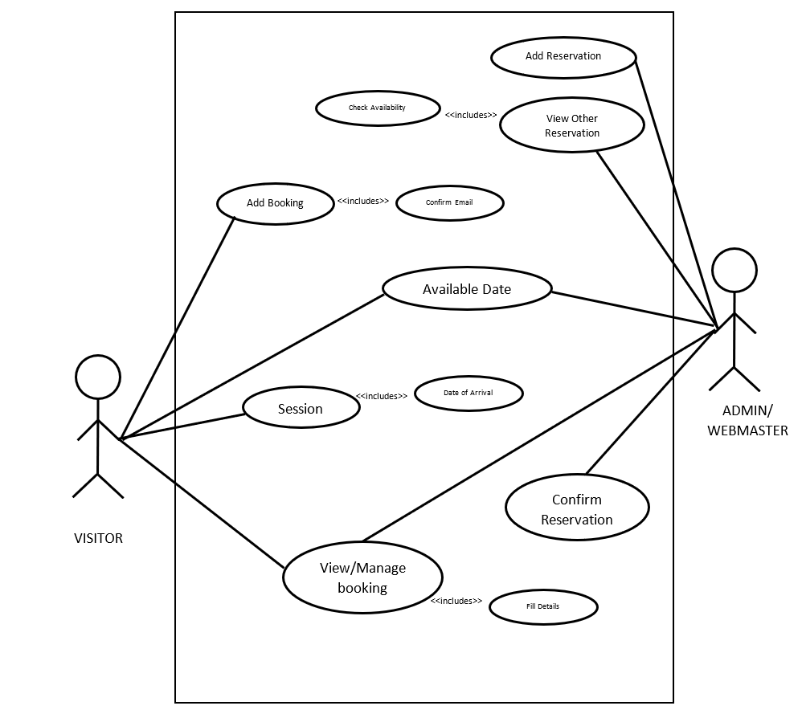

This figure shows the use-case diagram that shows and describes the context and objectives of an entire system to its users.

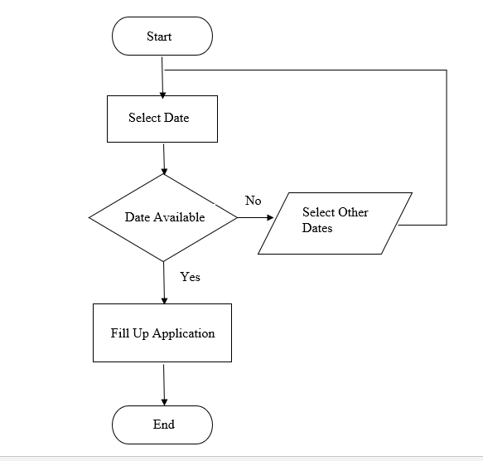

**Figure 13. Booking Admission Flowchart**

The figure shows the booking procedure done in the booking reservation website page.

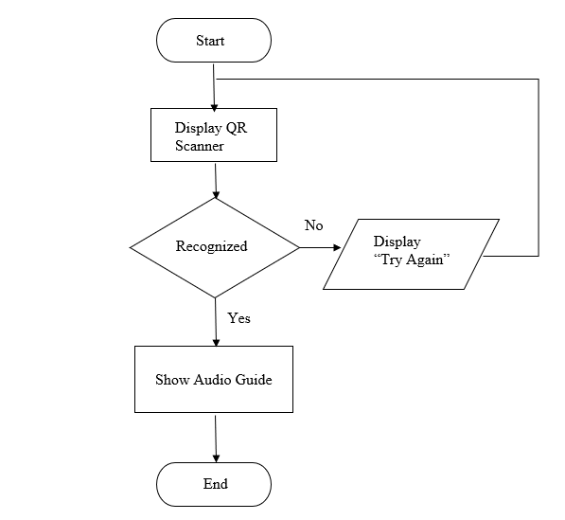

**Figure 14. QR Code Scan Flowchart**

The figure displays the process of scanning the QR code to access the Audio Guide feature for every exhibit in the museum.

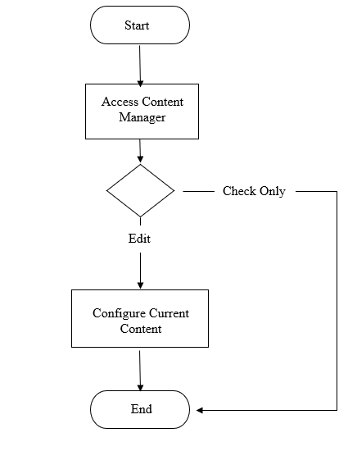

**Figure 15. Content Management Flowchart**

The figure displays the process on how the admin monitors and updates the website content.

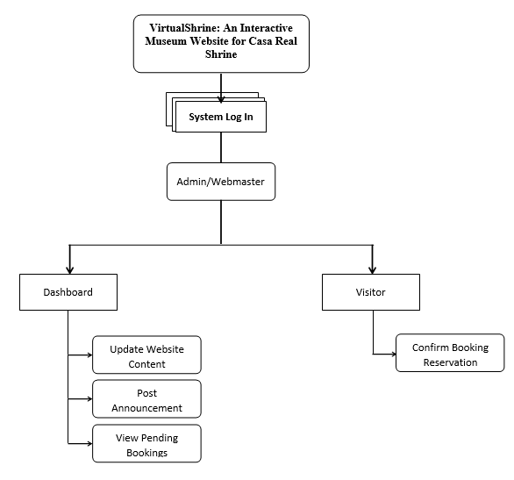

**Figure 16. Admin View VTOC**

This figure shows the whole flow of the Admin/Webmaster view of the VirtualShrine website content management system.

**Conceptual System Design**

The VirtualShrine: An interactive museum website for Casa Real is an interactive website that offers interactive features that would help the museum attract more visitors. One of the functionalities of the system is browsing the features and book reservation for the physical museum visit in the desired date and time of the visitors. Financial Transactions such as selling products from the museum gift shops are not included in this system. The system also does not require the visitor to register for an account, the only time that the system will ask for the visitor’s information is when they book for reservations.

**System Architecture**

Figure 4 shows the user’s access to the website via the internet through their computer terminal.

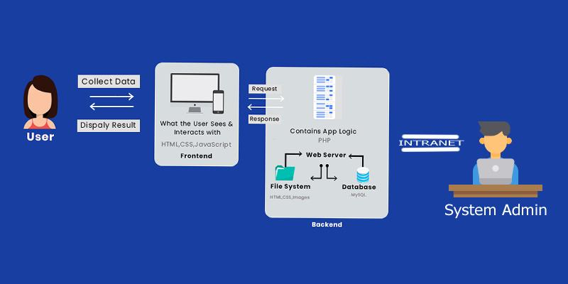

**Figure 17. The Client’s Access to the Website**

The web server replies and saves the client’s request to the database server.

The content manager can access the back office of the system via an intranet connection to maintain and update the system.

**Security Matrix**

This security matrix applies only on the Back-Office application. The matrix shows the accessibility rights of every user of the system.

The following are the different modules that the Administrator can access and modify, Upload/Update the contents of the museum like a virtual gallery.

**Table 5**

**Security Matrix**

|  |  |  |  |  |  |  |  |  |  |  |  |  |  |  |  |  |  |  |  |  |  |  |  |  |  |  |  |  |  |  |  |  |  |  |  |  |  |  |  |  |  |  |  |  |  |  |  |  |  |  |  |  |
| --- | --- | --- | --- | --- | --- | --- | --- | --- | --- | --- | --- | --- | --- | --- | --- | --- | --- | --- | --- | --- | --- | --- | --- | --- | --- | --- | --- | --- | --- | --- | --- | --- | --- | --- | --- | --- | --- | --- | --- | --- | --- | --- | --- | --- | --- | --- | --- | --- | --- | --- | --- | --- |
| |  |  |  |  | | --- | --- | --- | --- | | **Module** | **Head**  **Admin** | **Assistance  Admin** | **User** | | Log In | ✔ | ✔ |  | | View All Booking Reservation | ✔ | ✔ |  | | Approve/Decline Reservation | ✔ | ✔ |  | | Upload/Update website content | ✔ | ✔ |  | | View Website Content | ✔ | ✔ | ✔ | | Add User | ✔ |  |  | | View User Information | ✔ |  |  | | Edit User Information | ✔ |  |  | | Archive User | ✔ |  |  | | Book Reservation | ✔ | ✔ | ✔ | | Archive Contents | ✔ |  |  | | Update Personal Profile | ✔ | ✔ |  | |

**The Online Booking Reservation Process**

The booking reservation process of VirtualShrine can be done through online transactions as shown in Figure 6. However, there are some instances that the visitor is not actually using the internet to have their reservation. They visit the museum as walk-in customers.

In order to handle the data that will be submitted by the customer, the system will use a database server which is directly connected to a web server for internet connectivity. Maintenance, modifications, and update can be done by the administrator.

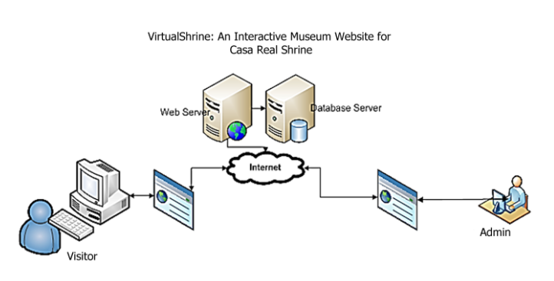

**Figure 18. Online Booking Process**

**The Walk-in Admission Process**

Figure 18 will show the illustration for the walk-in admission process. For the customer to make visiting admission, the following steps must be followed:

Step1: Customer inquiries at the Museum staff about the visiting slot availability.

Step 2: The Museum staff will log in to the System Back Office. He will ask for the date of reservation and what to reserve. Using the System, the museum staff can give the availability of the admission slots.

Step 3: Once the visitor decides to book for admission, the clerk will ask the user the basic information for profiling purposes.

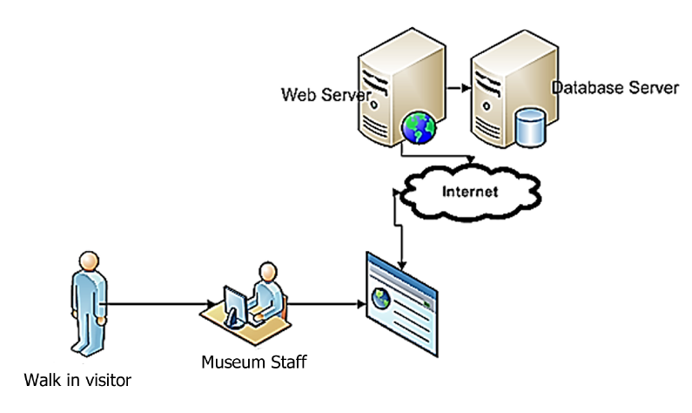

**Figure 19. Walk-in Admission Process**

**Network Infrastructure**

Figure 19 will show the network infrastructure of the VirtualShrine Website.

Since the proposed system is an interactive website, Internet connection is particularly important. As can be seen from the figure (Fig. 18), the visitor can browse the VirtualShrine website, and their reservation can be done.

Also, the system will allow website visitors to search for museum information such as operation hours and location from the museum website.

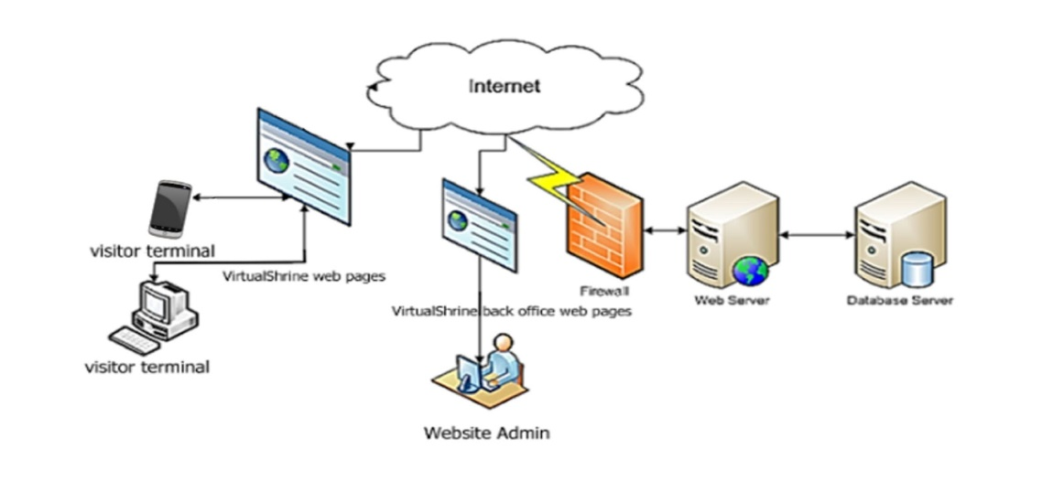

**Figure 20. The Network Infrastructure**

On the part of the Administrator (back-office account), the system will allow the Website Manager (administrator) to make modifications including updating the contents of the website. They can also approve and reject a booking from the visitor.  
  
**Description of Prototype**

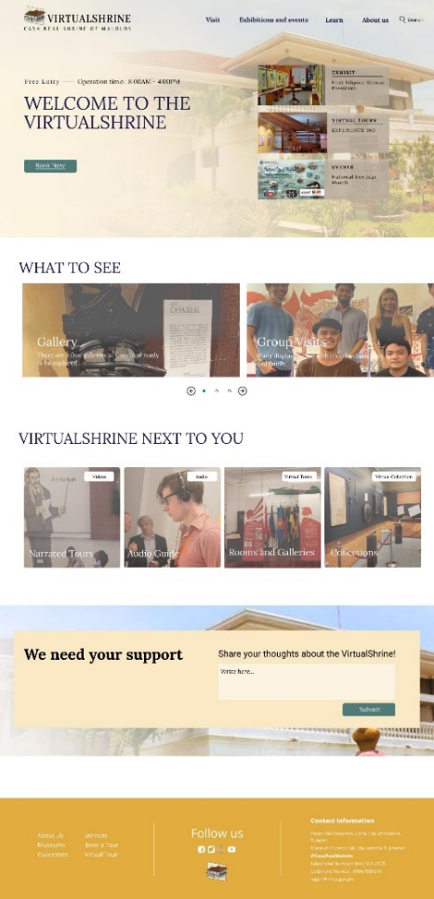

**Figure 21. VirtualShrine Homepage**

Figure 21 displays the home page of Casa Real Shrine. This page will be the default page shown in the browser when a user loads the website.

The following are what can be seen in the website homepage; (1) header. It is located on the top part of the website. The header includes the website logo, and navigation menu; (2) Welcome banner. The welcome banner displays a short welcome greeting for VirtualShrine visitors, the “Book a tour” and “Plan your visit” button, and the basic museum information such as the day and time of museum operation; (3) What to see. This part of the website will display an overview of what the visitor would see on the website; (4) Featured Exhibits. The main objective of this feature is to make the online visitors aware of the ongoing exhibits on the museum, this will serve as the exhibit promotion; (5) Upcoming Events. Announcement about the upcoming events in the museum will be displayed; (6) Museum Fundraising. This part of the homepage will serve as a promotion for the fundraising of the museum. and lastly; (7) Website Footer. It is located on the bottom part of the webpage, the footer includes the brief introduction about the Casa Real Shrine Museum, contact information, quick links, links to the museum social media accounts, and a copyright notice.

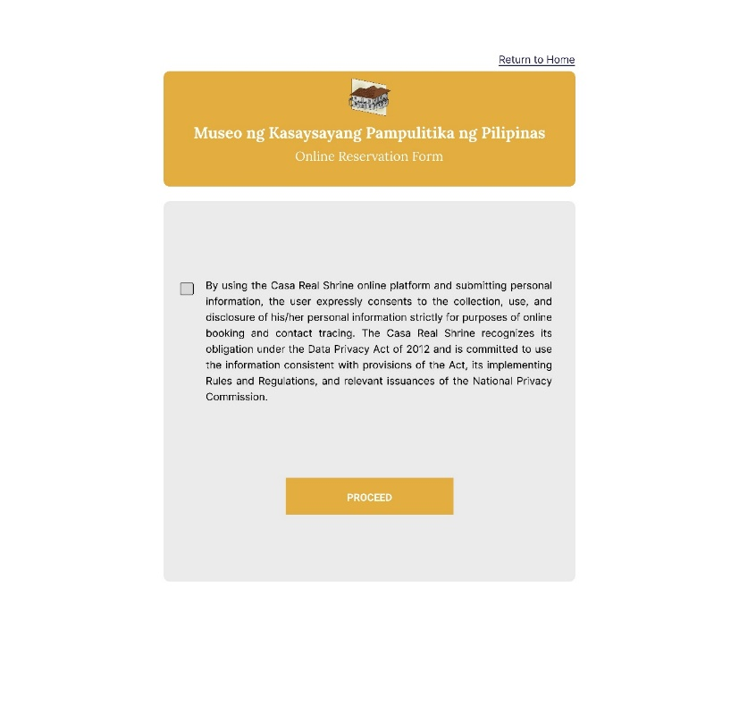

**Figure 22.** **Data Privacy Issue disclaimer**

Figure 22 displays the data privacy issue disclaimer, this will be displayed before allowing the visitor to proceed to the booking page, this page serves as a reminder and an agreement for both the museum and the visitor regarding the use of the data that will be provided by the visitor during the booking process.

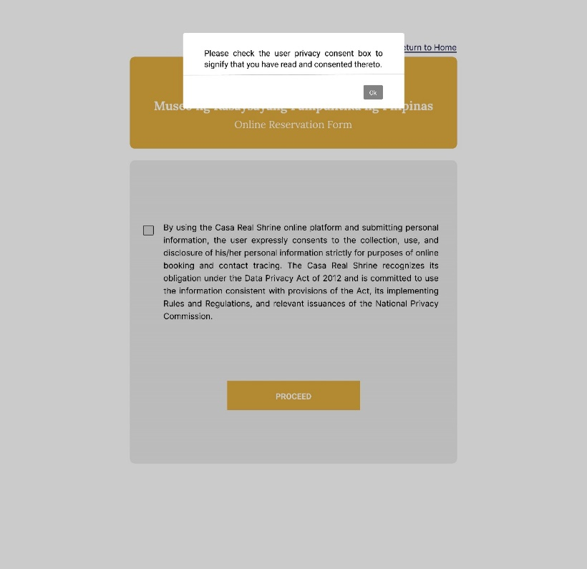

**Figure 23.** **Data Privacy Issue disclaimer – Warning**

The visitor will have to check the checkbox that means they agree to the terms and conditions. But if the visitors dis not click the checkbox and clicked the proceed button, the website will display a warning reminding them to click the checkbox first before proceeding.

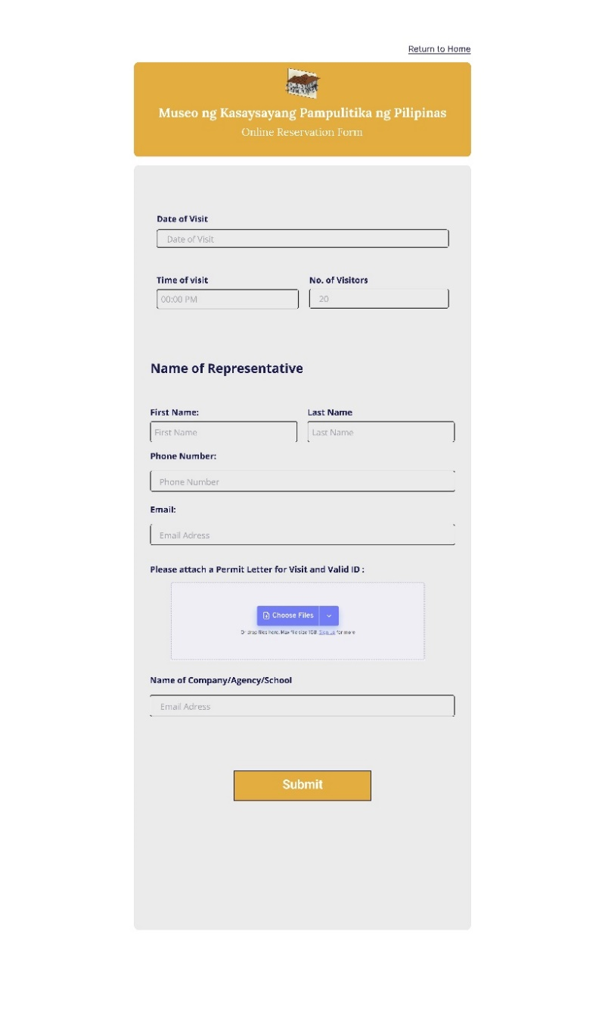

**Figure 24.** **Online Reservation Form page – Online Reservation Form**

Figure 24 displays the Online reservation form. the website will ask for the personal information of representative visitor, this includes the representative name, email for the confirmation of the reservation, Permit letter for the visit from the visitor’s institution or organization, and valid ID to confirm if the booking was from a legit individual or organization, and lastly, the name of company, agency, or school.

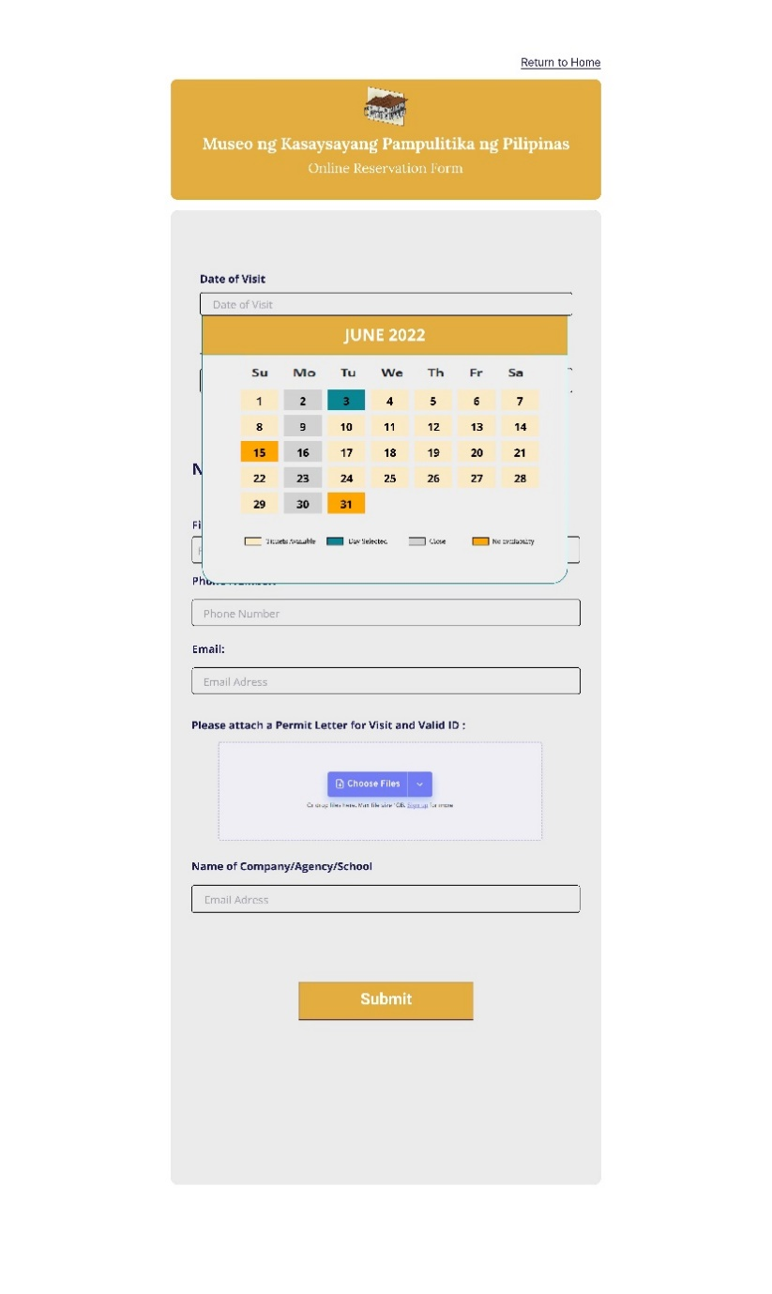

**Figure 25. Online Reservation Form page – Calendar**

The Online reservation form also provides a calendar. The availability of the date is presented through a color code; yellow means admissions are available, green is the day the visitor selected, gray means the museum is closed, and dark yellow for the dates that are not available.

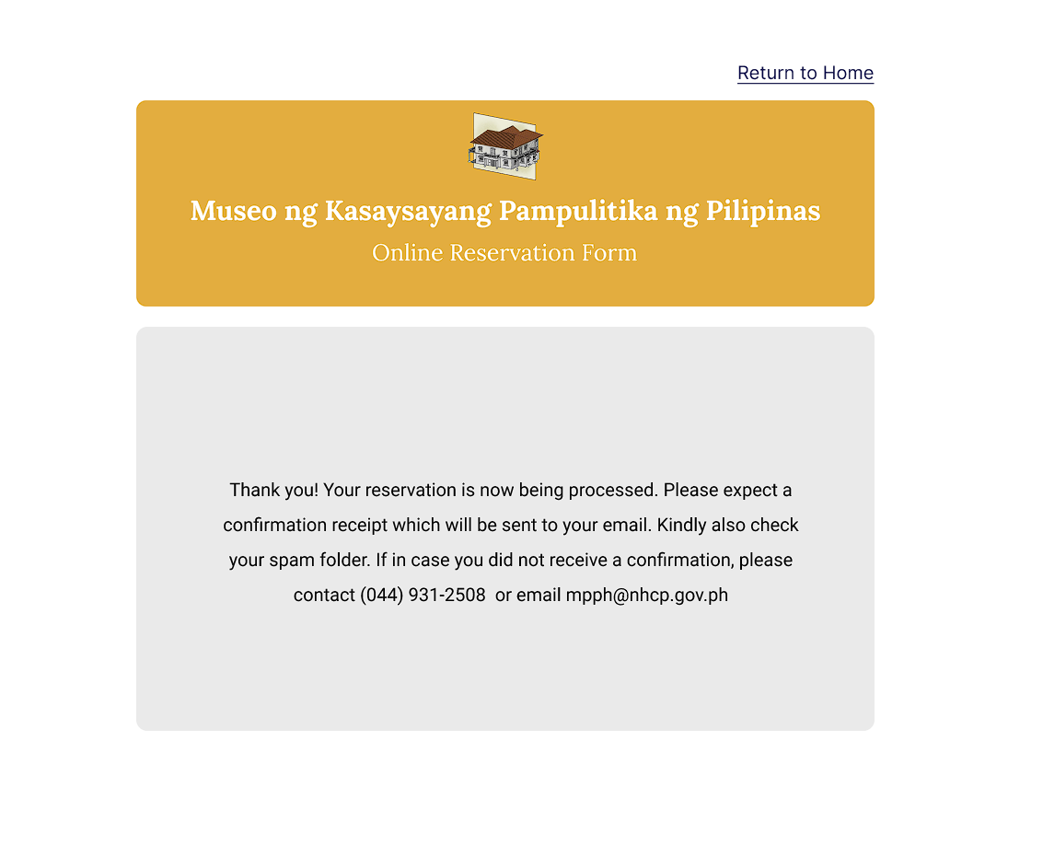

**Figure 26. Reservation Confirmation page**

Once the visitor successfully fills out the form, the website will display a confirmation message.

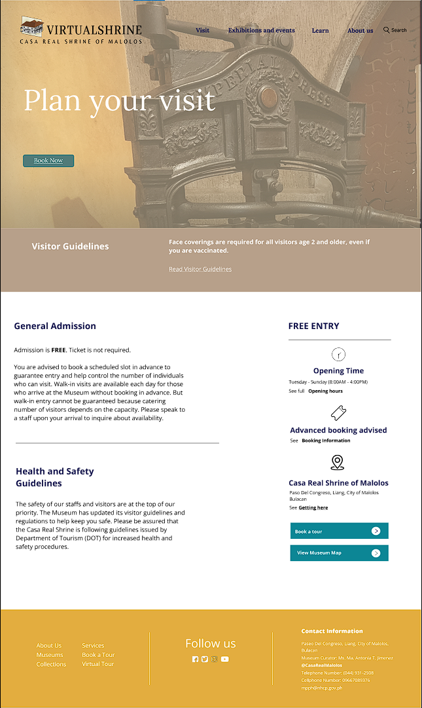

**Figure 27. Plan your visit page**

Figure 27 shows the ‘plan your visit’ page. This is where the VirtualShrine visitors could view the general information they need to know before they visit the physical museum. This page includes the information about the General Admission and Health and Safety guidelines, museum operation date and time, location, and the thumbnails that link to another page such as the galleries, educational tours, and exhibitions and events.

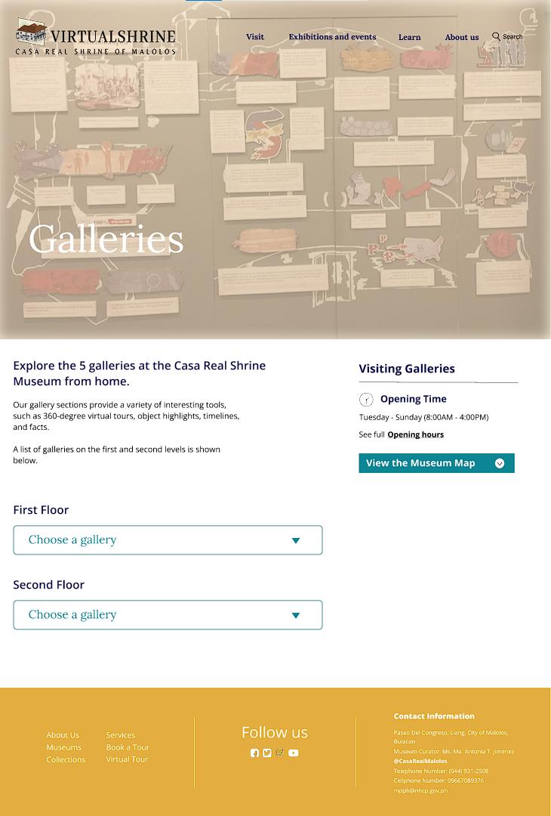

**Figure 28. Galleries page**

Figure 28 shows the Virtual Shrine website's Galleries page. This page allows website visitors to browse the museum's galleries. Each gallery is distinguished by the floor on which it is placed. The proponents did this so that the VirtualShrine visitor would know on which floor each gallery is placed.

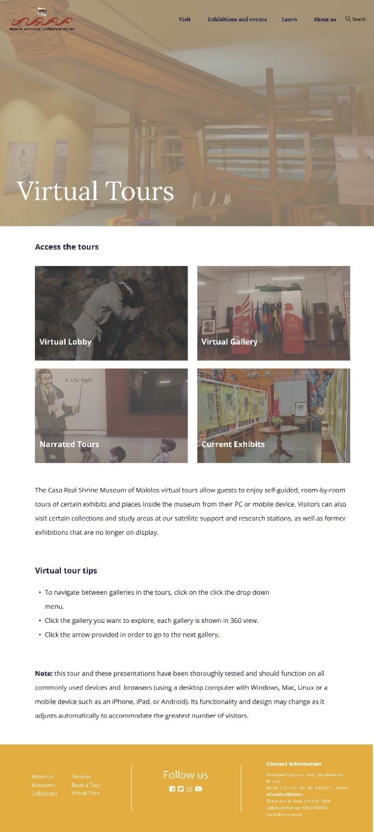

**Figure 29. Virtual Tours page**

Figure 29 displays the VirtualShrine’s virtual tours page. This page displays the virtual museum tours for the VirtualShrine visitors.  The goal is for website visitors to be able to experience the museum without having to visit the real museum. This page also contains virtual tour tips that could assist website visitors in navigating the tours so that they can enjoy the virtual tour without difficulty.

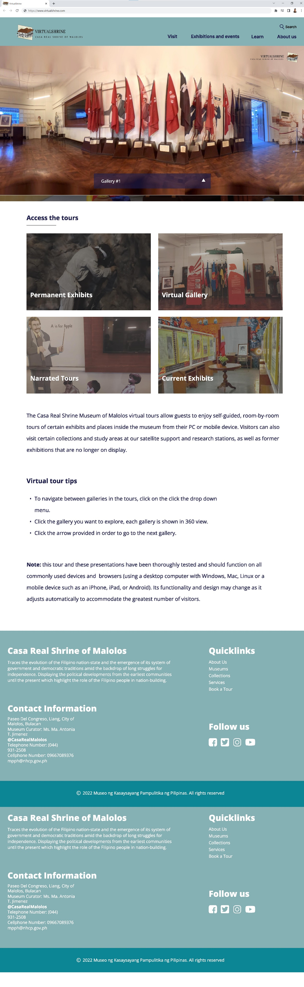

**Figure 30. Virtual Tour – Gallery 360° View**

Figure 30 displays one of the VirtualShrine feature, the Virtual Gallery 360° view. This feature is added into the website to allow the VirtualShrine visitor witness how the inside of the Casa Real looks like.

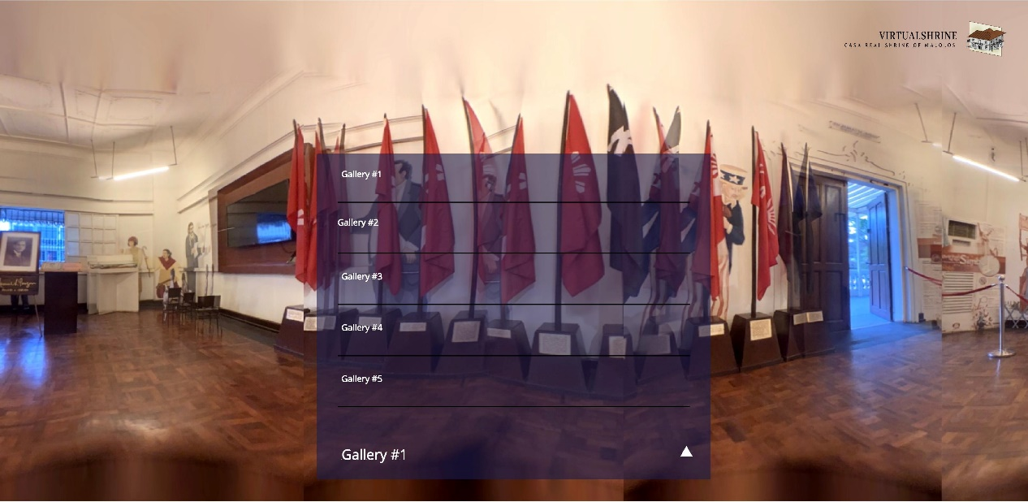

**Figure 31. Virtual Tour – Gallery 360° View Navigation**

Figure 31 illustrates how the visitor of VirtualShrine can go from one gallery to another. By selecting an option from the drop-down menu, the website will display gallery selections, from which the visitor can select the next gallery to explore.

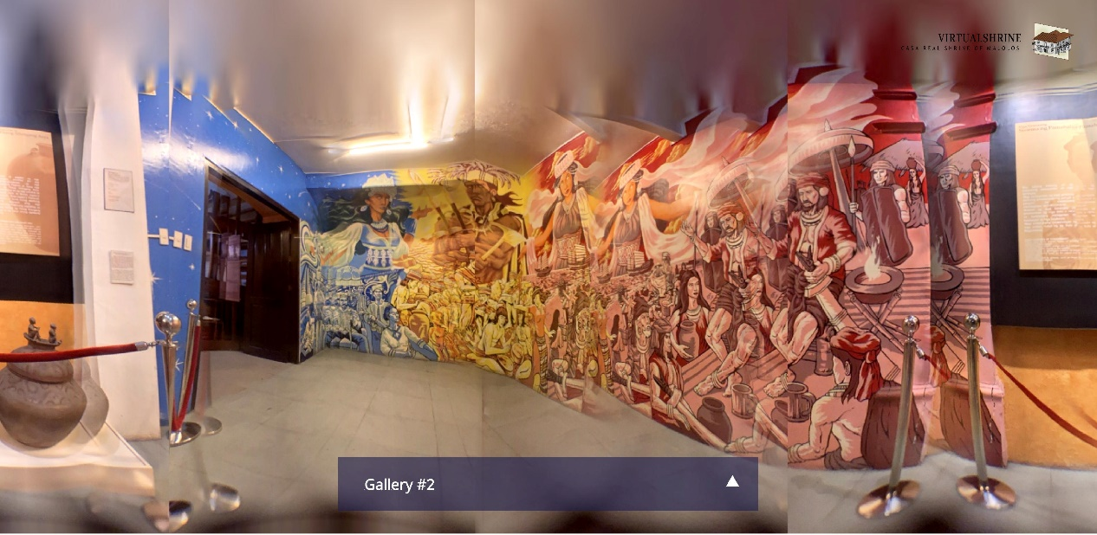

**Figure 32.** **Virtual Tour – Gallery 360° View Navigation**

Once the VirtualShrine visitor clicks on any of the gallery on the drop-down menu, the website will automatically redirect the visitor to the chosen gallery.

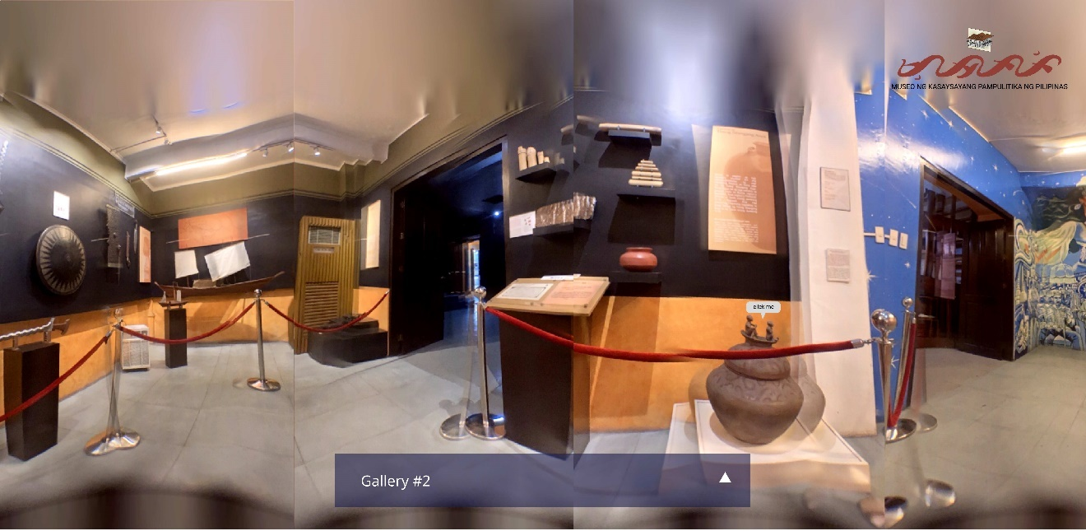

**Figure 33.** **Virtual Tour – Gallery 360° Display Short Information**

Figure 33 displays the Short Information navigation of the display. The visitor will just have to click the “click me” button found right next to the display

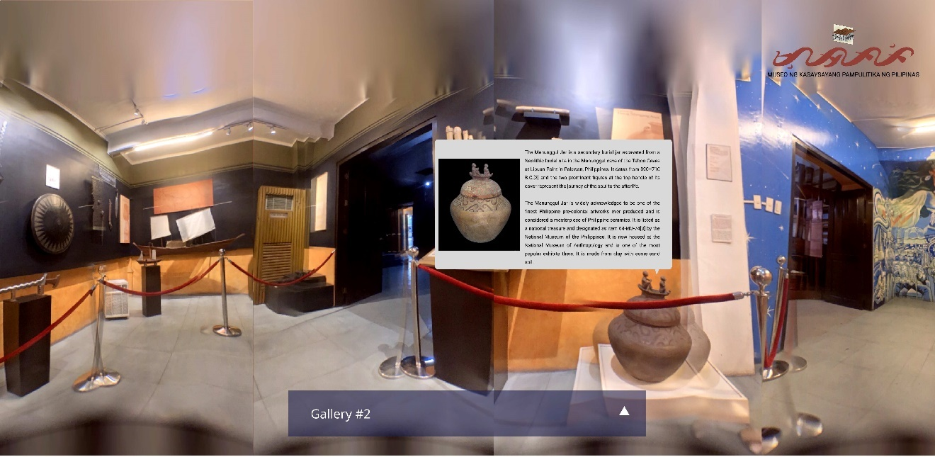

**Figure 34.** **Virtual Tour – Gallery 360° Display Short Information**

After clicking the “click me” button, the website will automatically display the short information regarding the display.

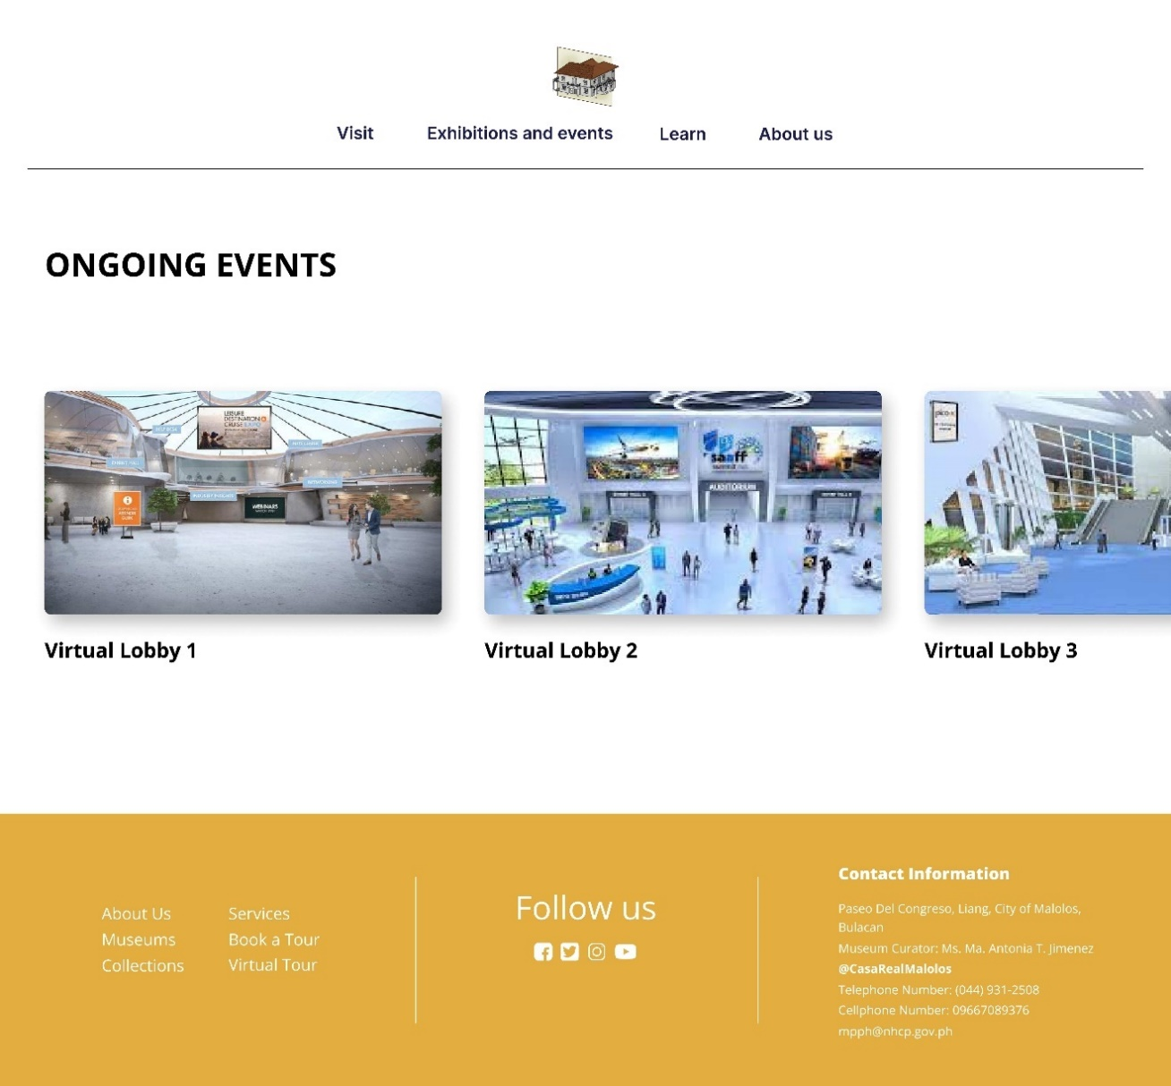

**Figure 35.** **Virtual Tour - Virtual Lobby Events**

Figure 35 displays one of the features of the virtual tour. The Virtual Lobby. On this page, it displays all the avialble events that the visitor can join in to.

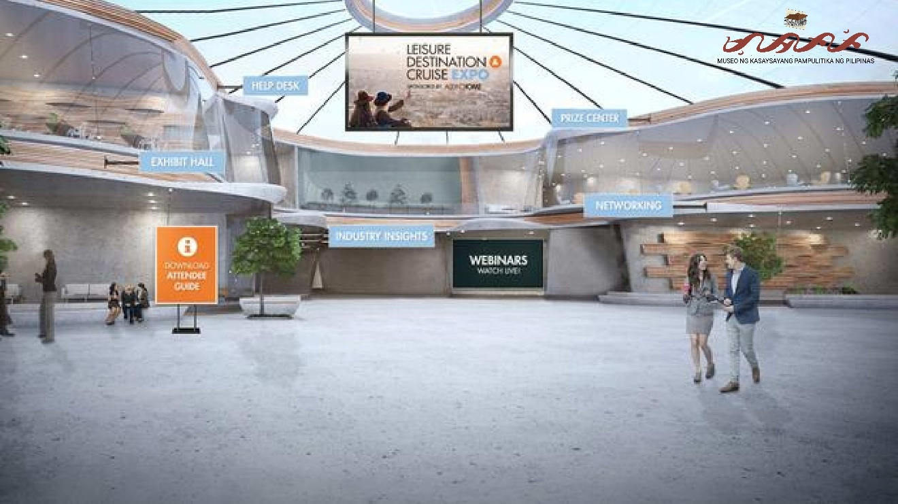

**Figure 36. Virtual Lobby**

Figure 36 displays the virtual lobby where the even are being help. There will be interactive features that the visitors can use, like help desk, exhibit halls, and more depending on the type of event that is being held.

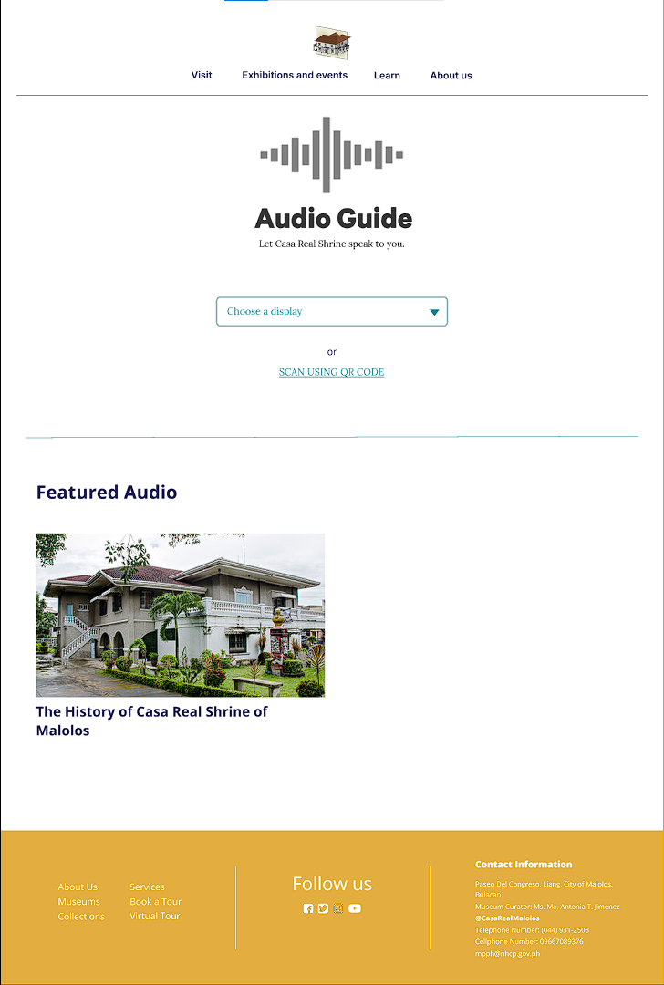

**Figure 37. Audio Guide**

Figure 37 shows the Audio Guide page of the VirtualShrine. This is one of the features offered in the VirtualShrine, the purpose of this feature is to deliver a spoken commentary about the exhibit or display. This feature will allow the visitors to have more flexibility as they explore throughout the museum.

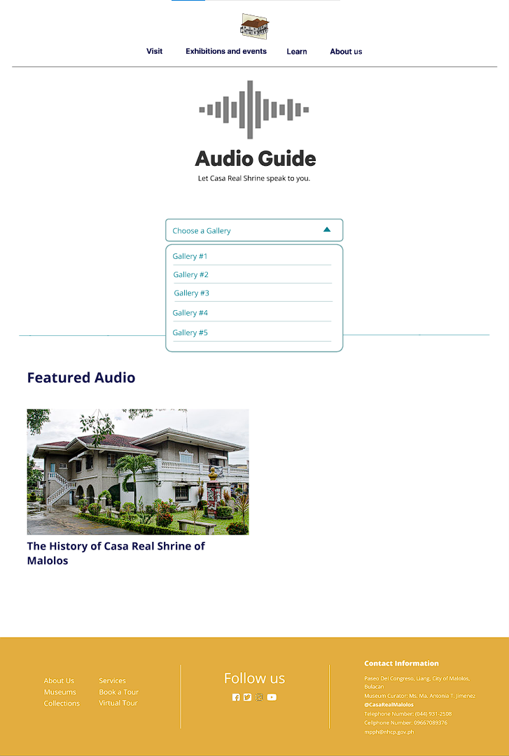

**Figure 38. Audio Guide – Choose a gallery**

Figure 38 displays how to access the audio contents, the visitor must first choose a gallery from the drop-down menu.

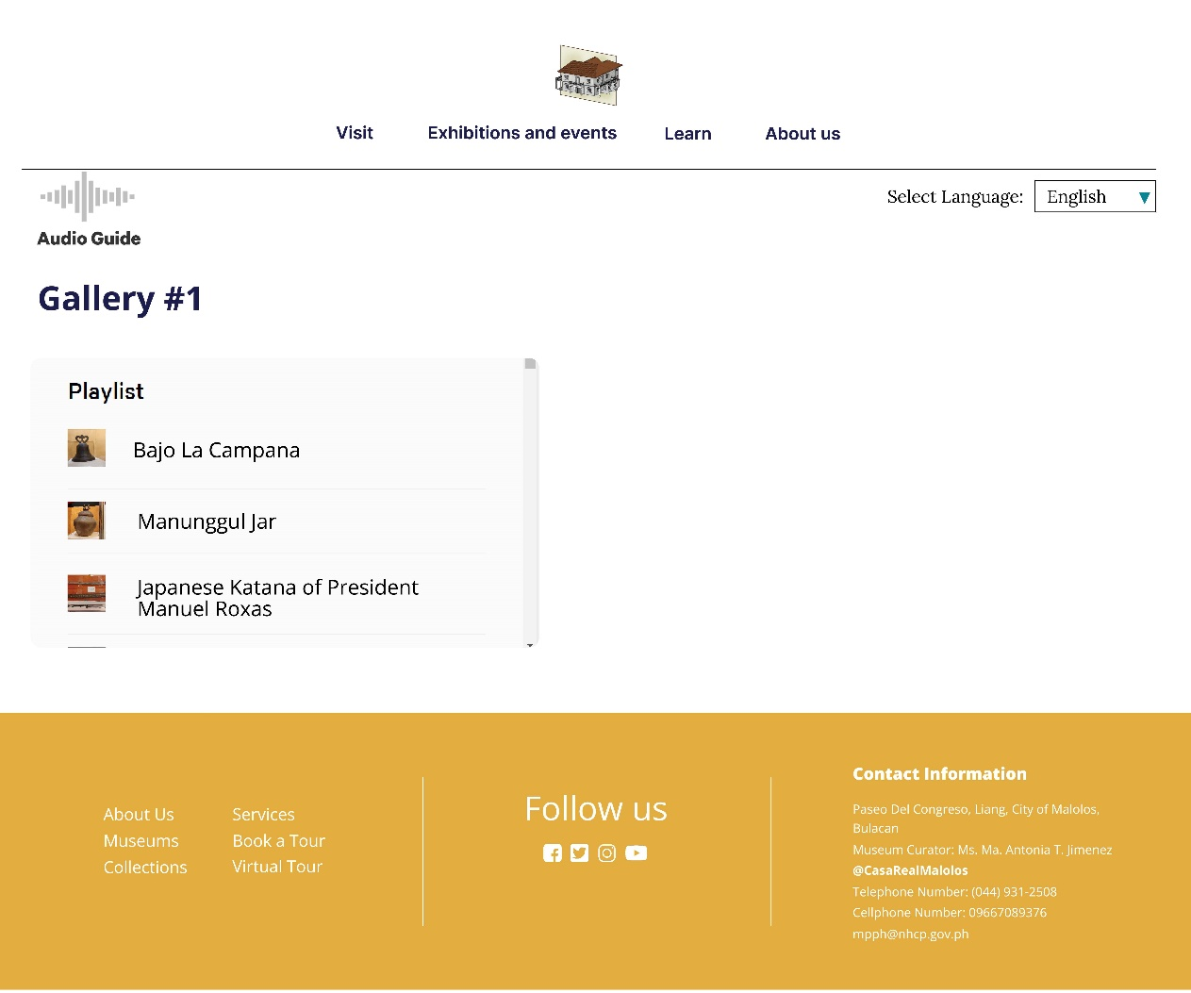

**Figure 39. Audio Guide – Gallery Playlist**

Once the visitor chooses a gallery, the website will redirect to the Gallery playlist where all the audio guides for the specific galley are displayed. The visitor can also choose a language they desire, they can select a language on the radio button located at the upper part of the page. After choosing a language, the visitor can now choose any audio to play.

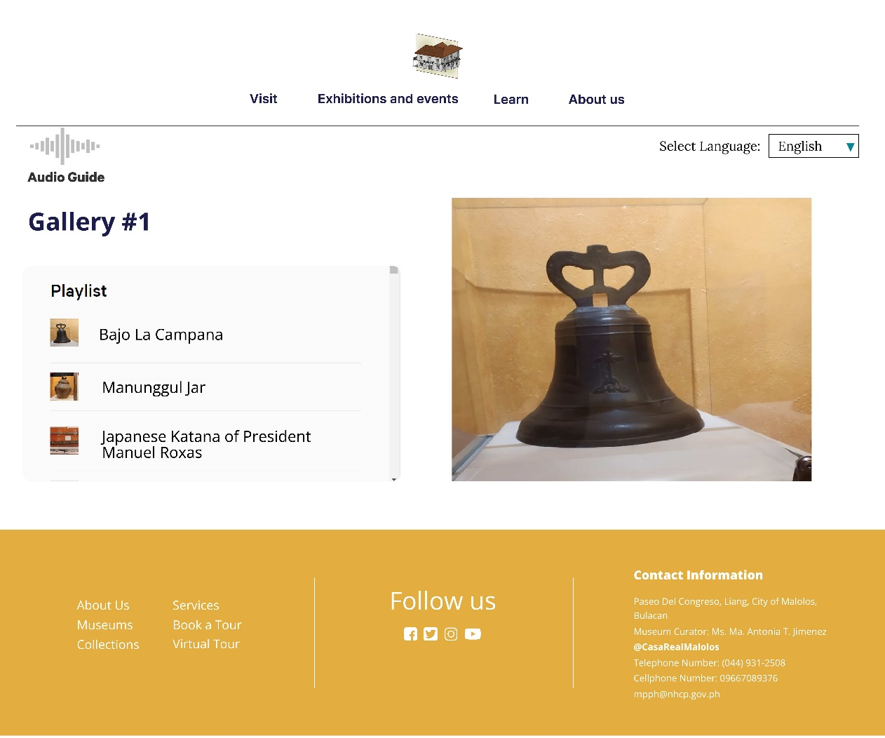

**Figure 40. Audio Guide**

After the visitor chooses an audio from the playlist. The website will automatically play the audio.

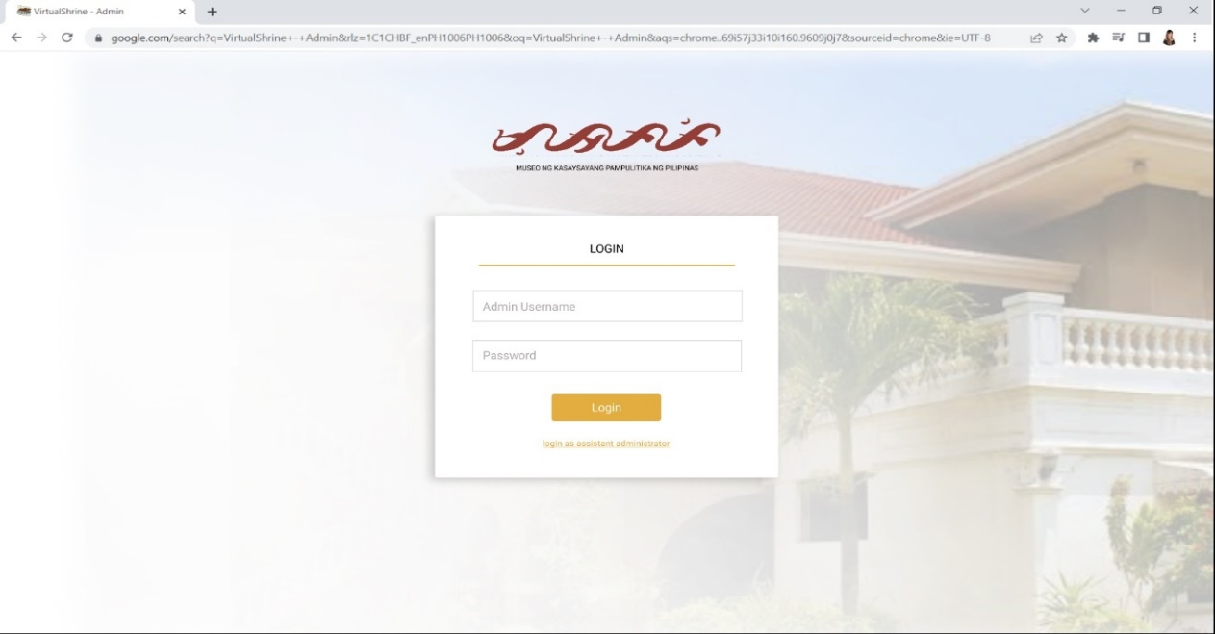**Figure 41. Head Admin – Log in page**

Figure 41 displays the Log in page for the head admin.

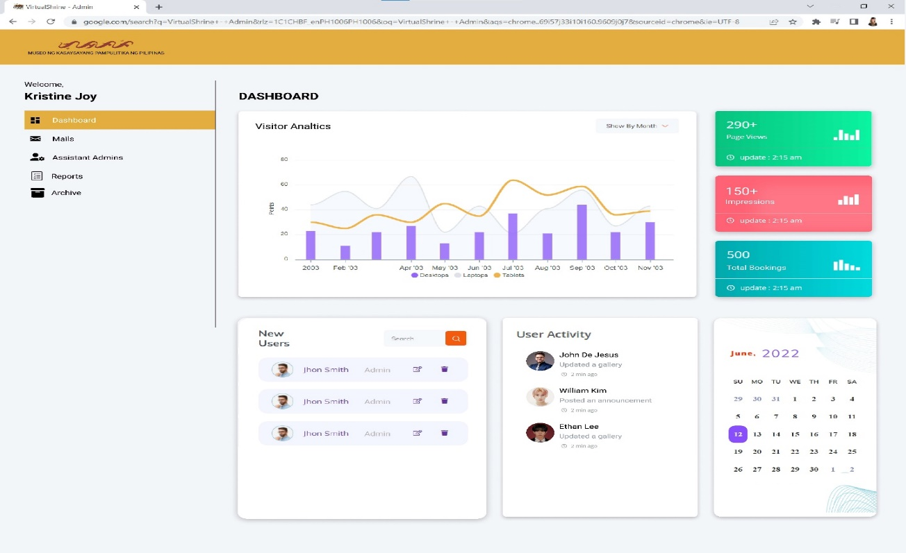

**Figure 42.** **Head Admin – Main Dashboard**

Figure 42 shows the Main dashboard for the head admin. Once the head admin successfully signs in into the system, they will be able to access the main dashboard. The main dashboard displays a visual statistical presentation of the Visitor analytics, widgets displaying the new users/admins, user/admin activity, and calendar.

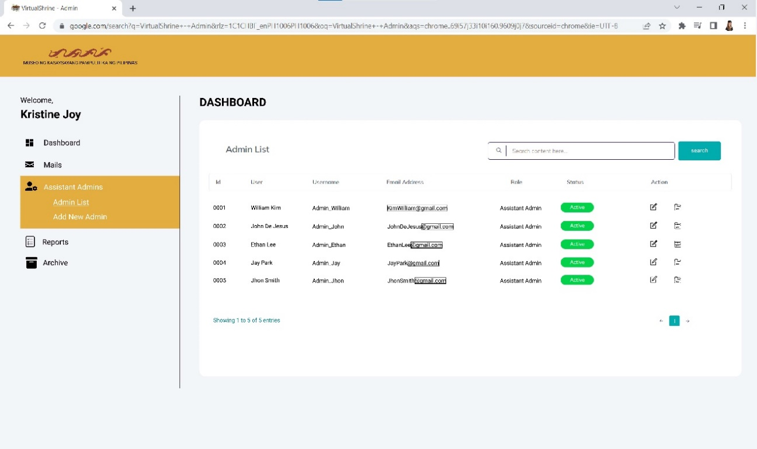

**Figure 43. Head Admin – Assistant Admin Menu**

Figure 43 displays the Assistant Admin Menu of the main admin dashboard. This is where the main admin will be able to view and manipulate the assistant admin information, actions such as edit, and archive of user information is provided.

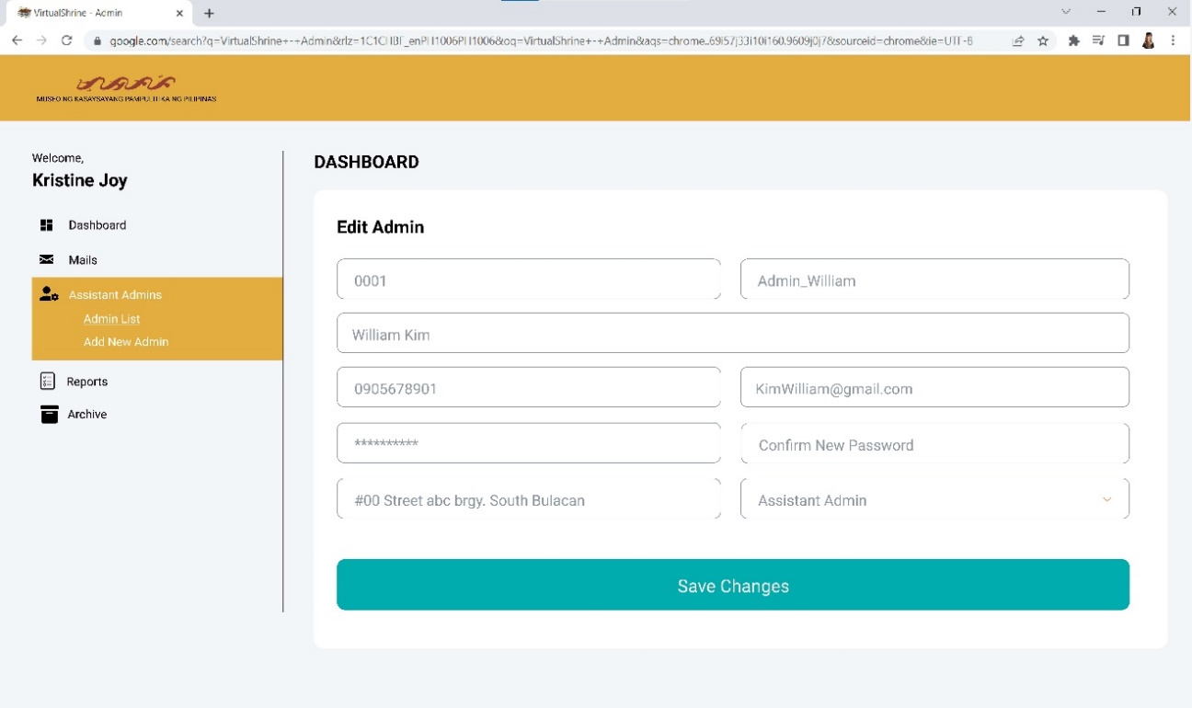

**Figure 44. Head Admin – Edit User Information**

Figure 44 displays the Edit User Information page of the admin dashboard. This page allows the main admin to edit the existing user information.

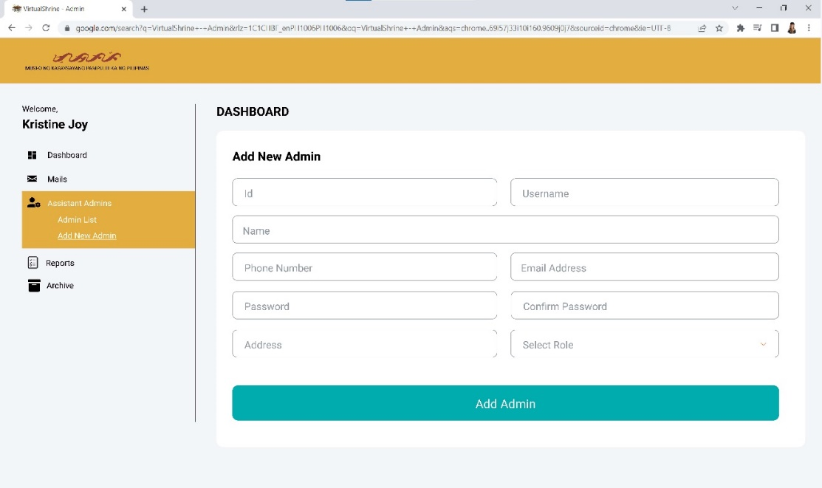

**Figure 45. Head Admin – Add a new Admin**

Figure 45 displays the Add a new admin page, this page allows the head admin to add a new assistant admin into the system. The main admin just has to provide the information such as the ID, Username, Name, Phone number, Email Address, Password, Address, and the Role.

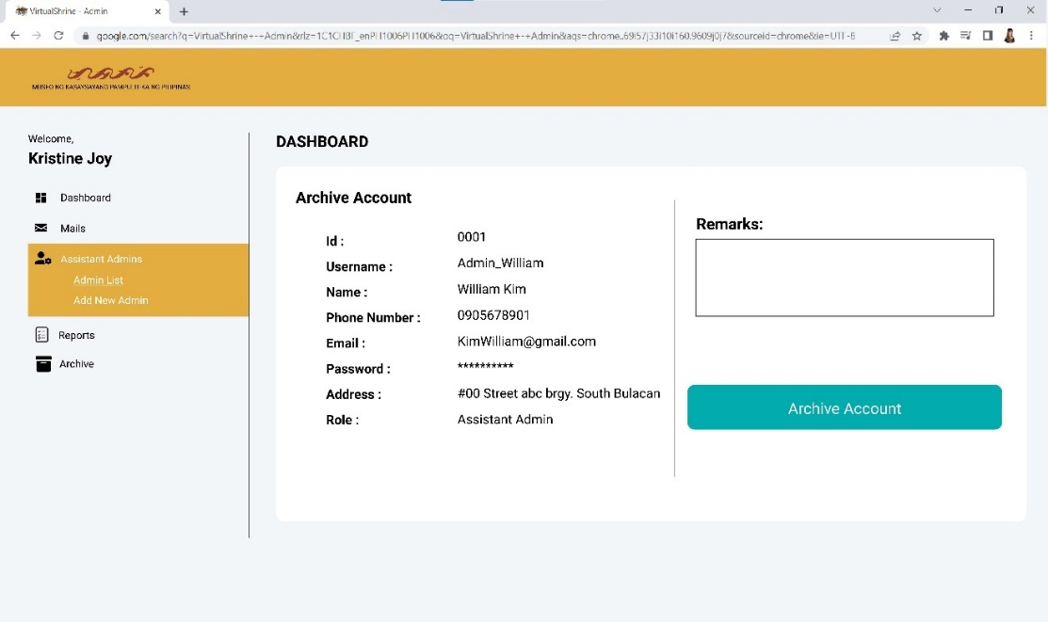

**Figure 46. Head Admin – Archive Account**

Figure 46 displays the Archive Account page of the admin dashboard. This page will allow the admin to archive an account that is no longer being used. The main admin will have to provide the reason for archiving the account in the remarks area. After doing so, the admin can proceed to click the archive account button and the system will save the account on the archives.

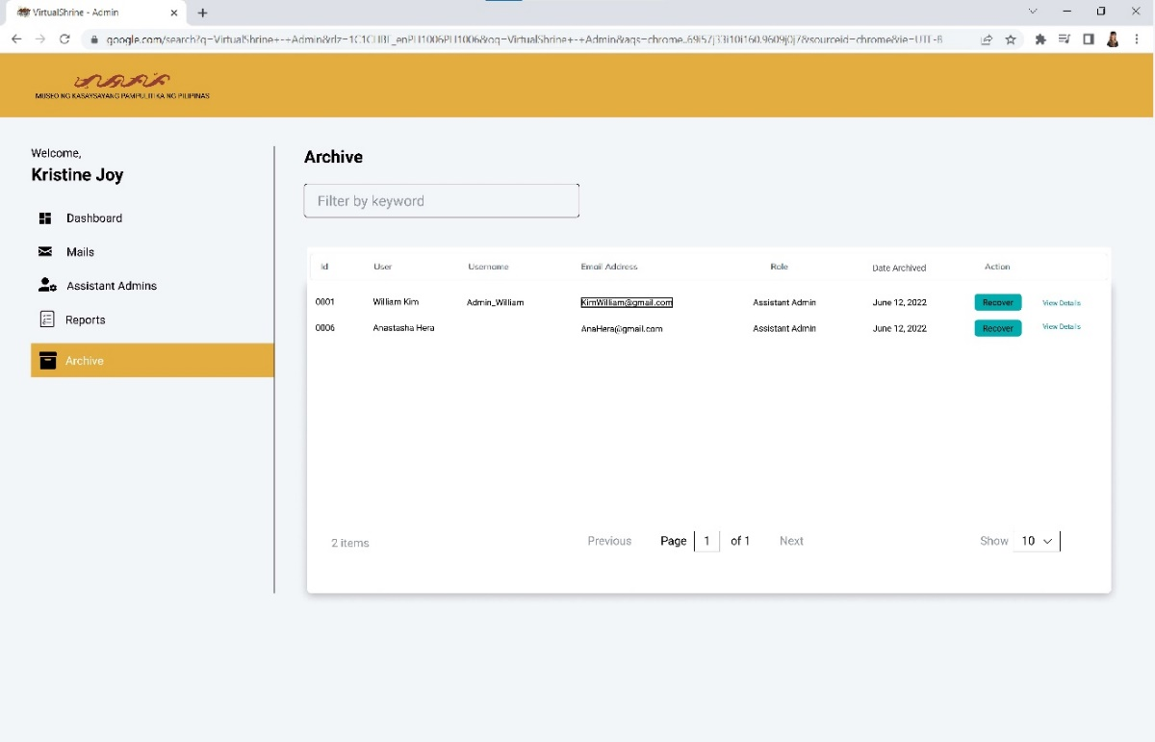

**Figure 47. Head Admin – Archive Menu**

Figure 47 displays the Archive Menu of the Main Admin dashboard. This page displays the accounts that have been archived by the main admin.

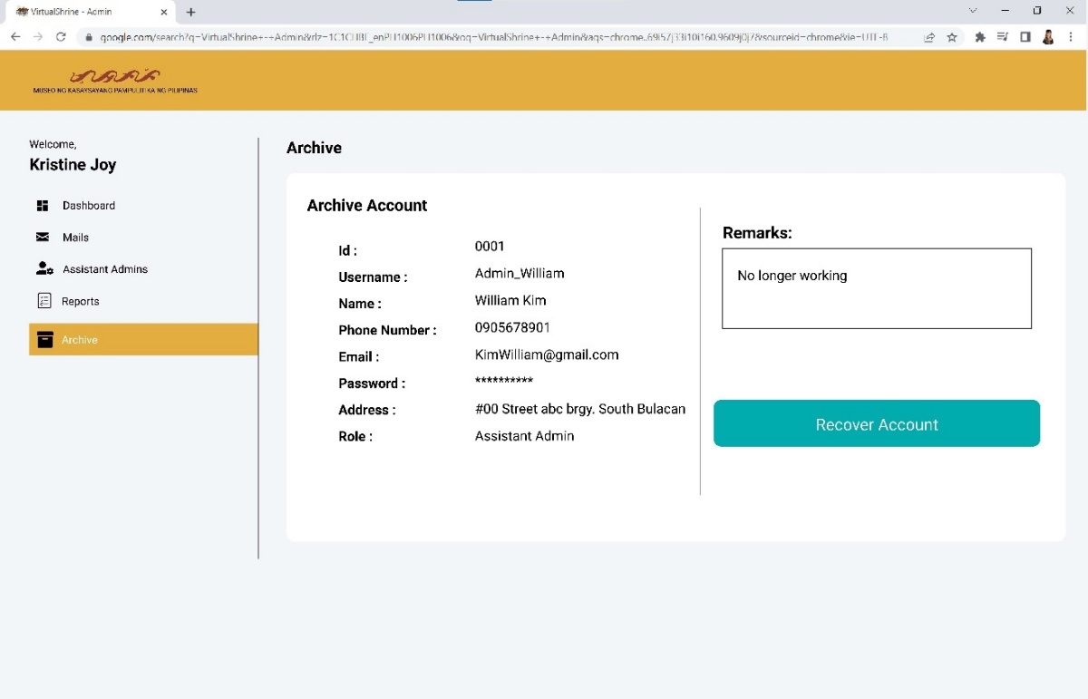

**Figure 48. Head Admin – View Archived Account details**

Figure 48 displays the details of the archived account where all the information of the previous user is stored, also the remarks of the main admin.

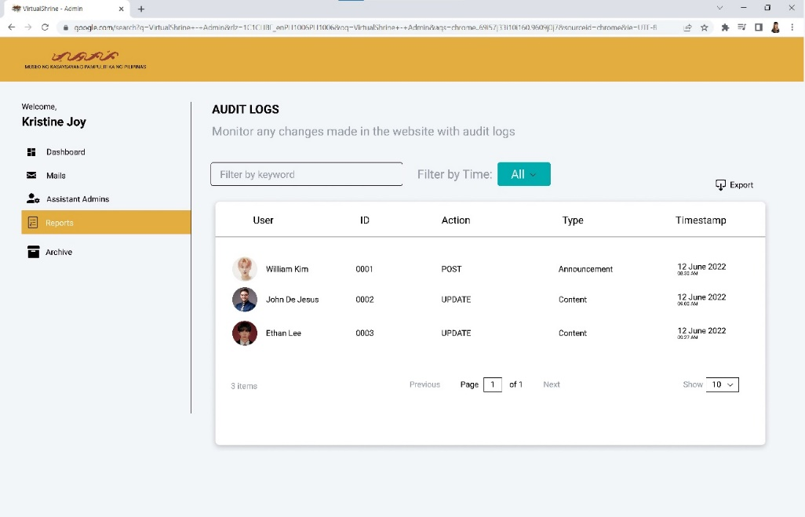

**Figure 49. Head Admin – Audit Logs Menu**

Figure 49 displays the Audit Logs Menu of the Main admin dashboard. This page will display the actions done by the assistant admins, and this will allow the main admin to monitor the changes made on the website by the assistant admins, this will also serve as a tracking record. The export button will allow the admin to print the audit log for documentation purposes.

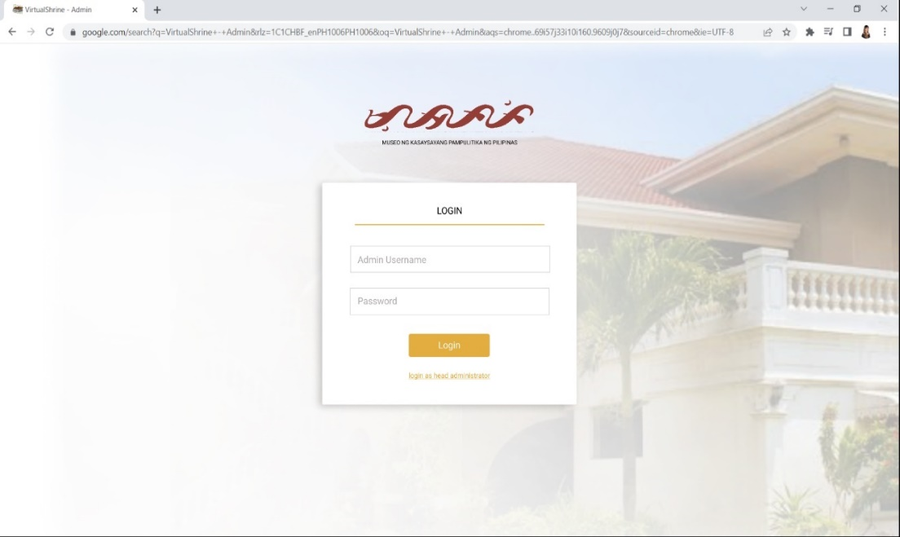

**Figure 50. Assistant Admin – Sign in page**

Figure 50 displays the assistant admin sign in page. This page will allow the assistant admin to access the dashboard. Only those users who were created by the head admin will be able to access the dashboard.

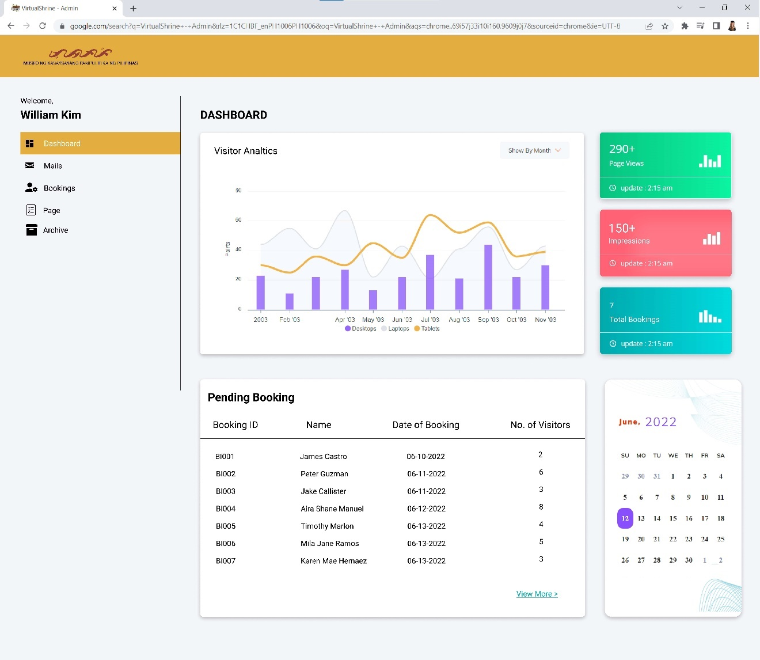

**Figure 51.** **Assistant Admin – Dashboard**

Figure 51 displays the Assistant Admin dashboard. If the user successfully signs in into the system using the username and password provided by the head admin, they will be able access the assistant admin dashboard. This dashboard displays the Visitor Analytics, Website Visit and Impressions, total Bookings, Pending bookings, and the calendar.

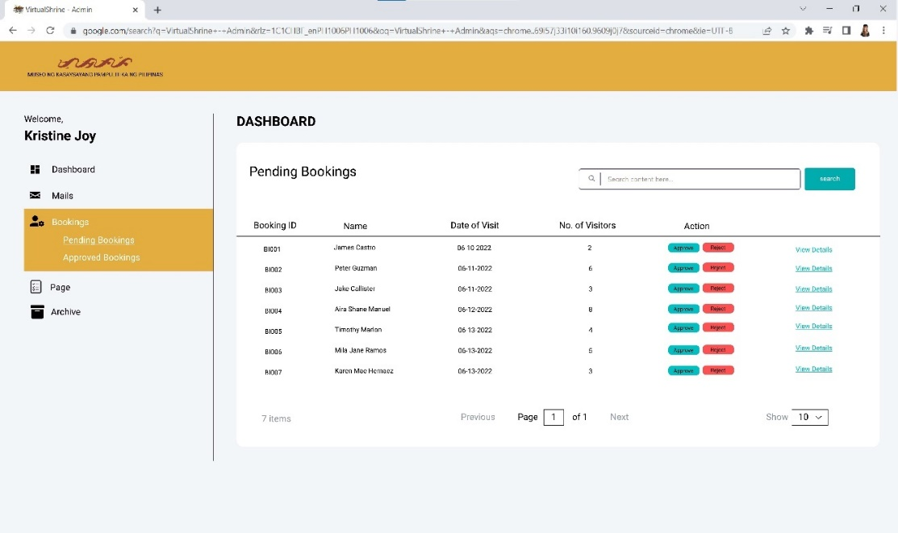

**Figure 52. Assistant Admin – Pending Bookings**

Figure 52 displays the Pending Bookings page where all the pending visitor bookings are displayed. This page allows the assistant admin to check and validate the submitted bookings, the assistant admin can approve or reject the bookings.

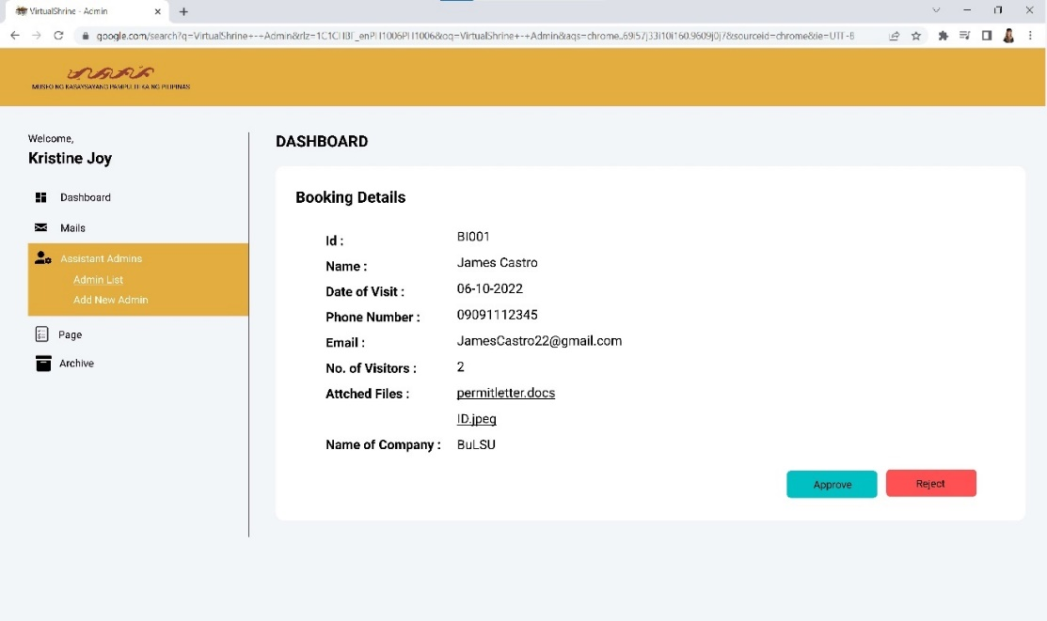

**Figure 53. Assistant Admin – Booking Details**

Figure 53 displays the booking details page; this page allows the assistant admin to view the full booking information of the visitor. The approve or reject button is also provided on this page.

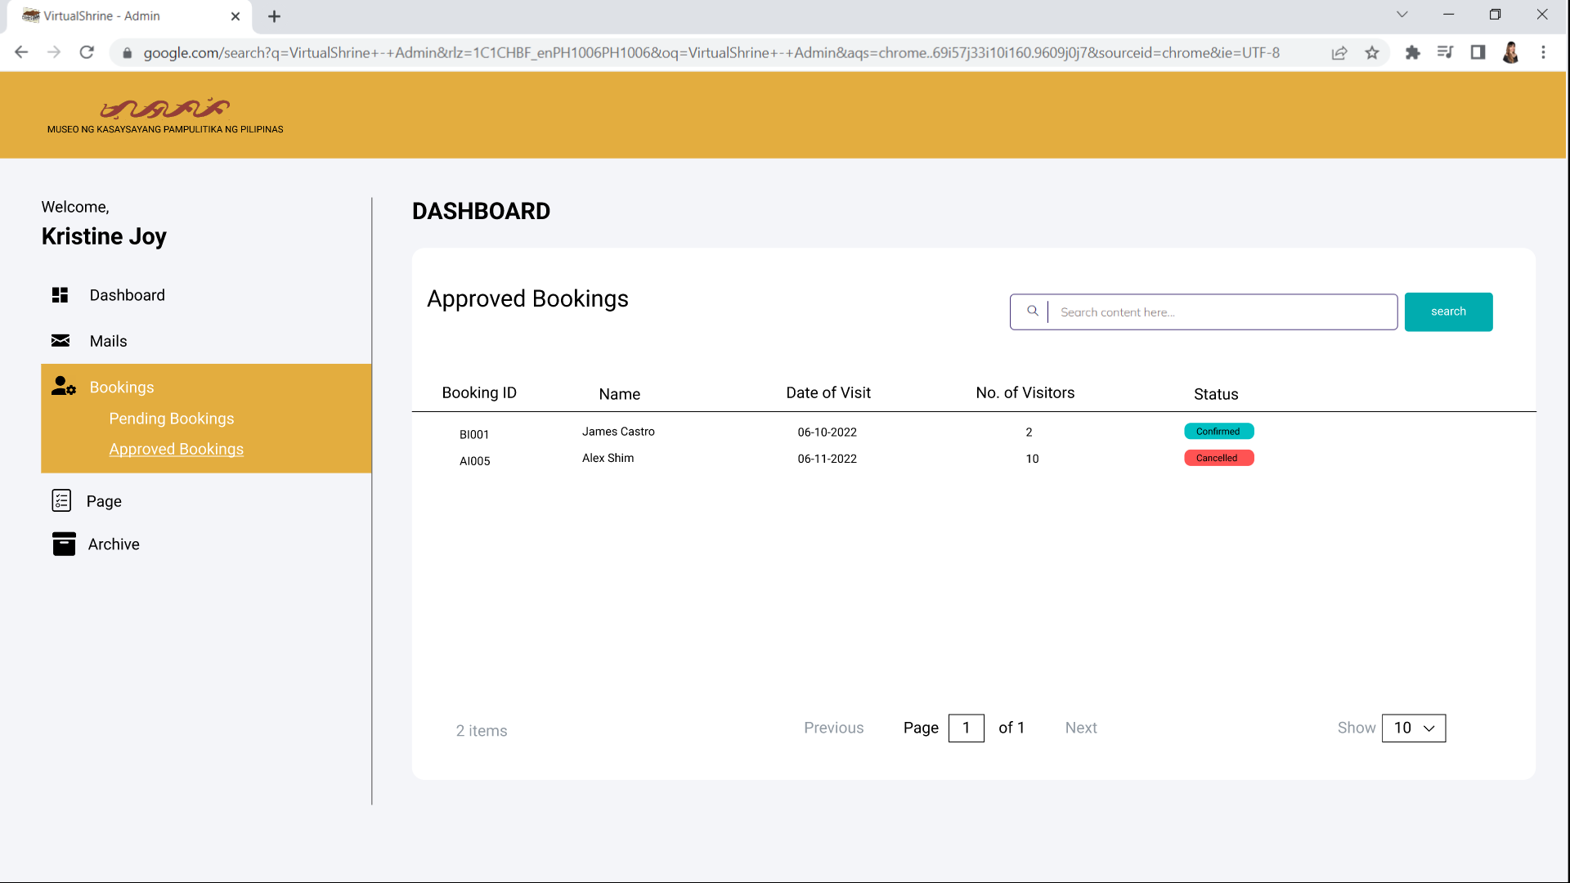

**Figure 54. Assistant Admin – Approved Bookings**

Figure 54 displays the Approved Bookings page. This page displays all the bookings that has been approved by the assistant admin. This page also display the status of the booking visit, whether if the booking is either confirmed or cancelled by the visitor.

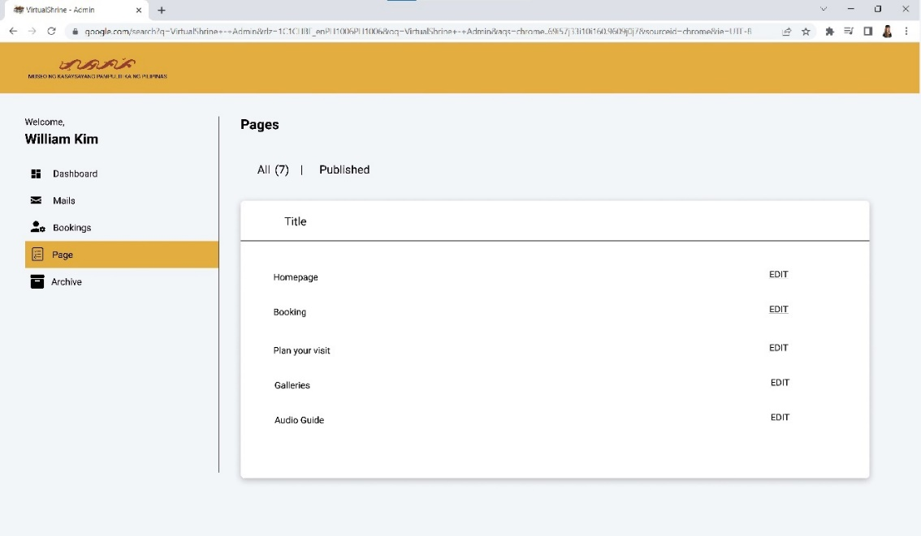

**Figure 55. Assistant Admin – Content Management**

Figure 55 displays the Content Management page. This is where the assistant admin be able to manipulat and update the web pages.

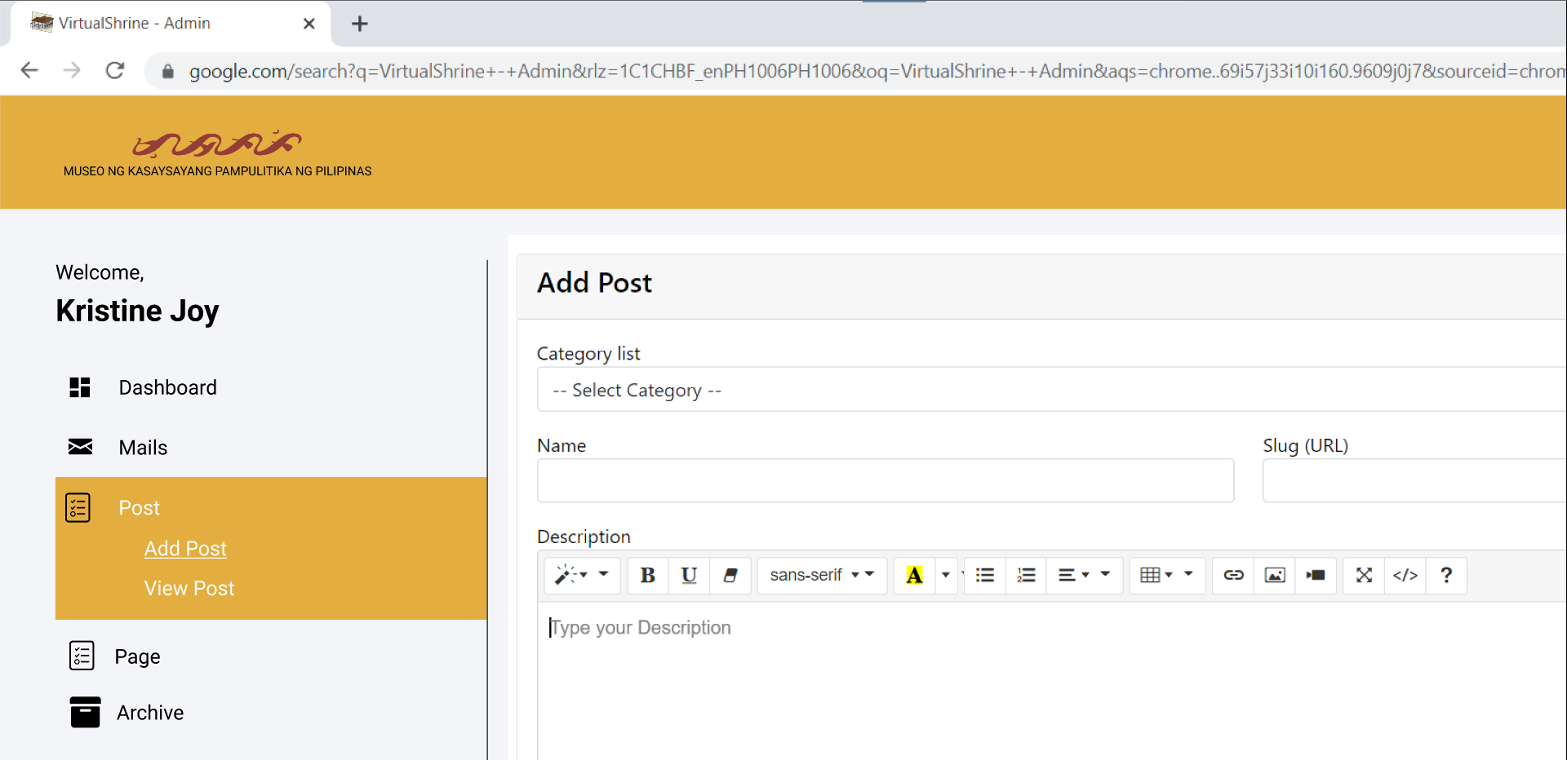

**Figure 56. Assistant Admin – Add Post**

Figure 56 displays the add post dashboard in Assistant Admin panel. This dashboard menu allows the admins to post a content on the website.

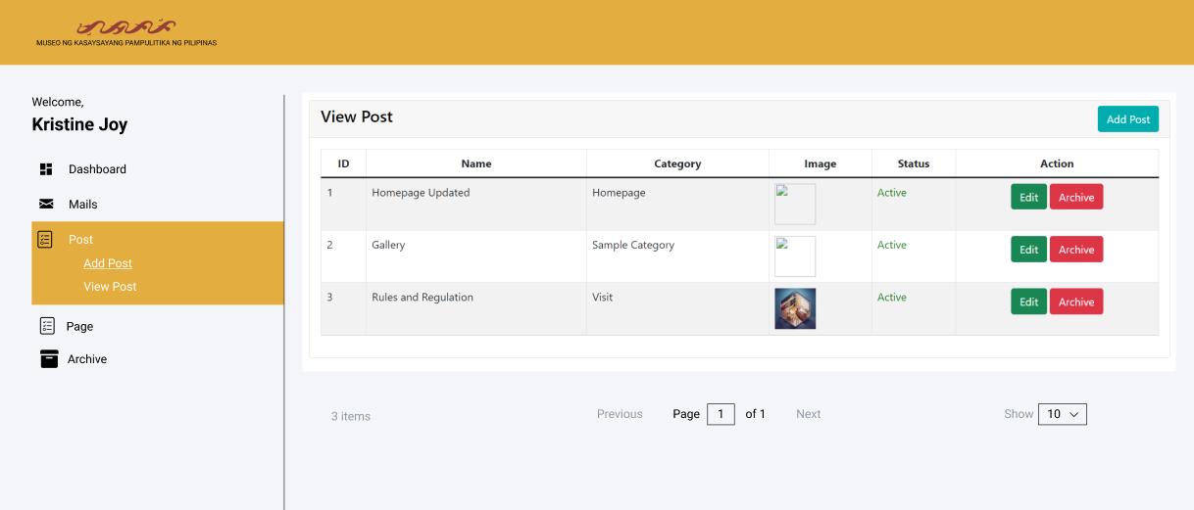**Figure 57. Assistant Admin – View Post**

Figure 57 displays the view post dashboard in Assistant Admin panel. This dashboard menu allows the admins to view the contents uploaded on the website. This dashboard also allows admin to make actions towards the post such as editing or archiving a post.

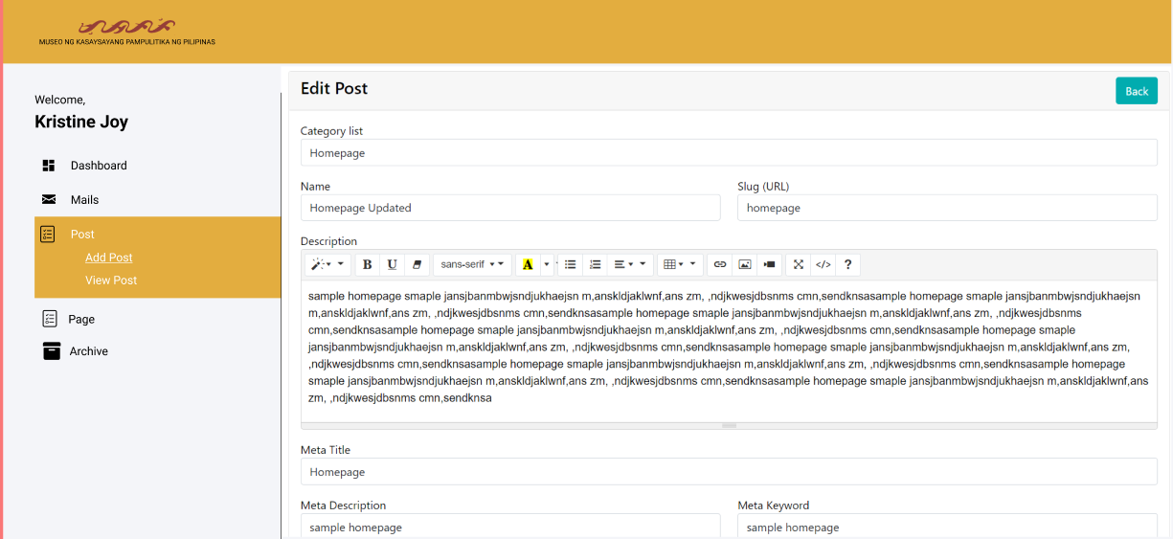

**Figure 58. Assistant Admin – Edit Post**

Figure 58 displays the edit post dashboard in Assistant Admin panel. This feature allows the admins to edit a post.